UNITED STATES
SECURITIES AND EXCHANGE COMMISSION
Washington D.C. 20549
FORM 8-K
CURRENT REPORT
PURSUANT TO SECTION 13 OR 15(d)
OF THE SECURITIES EXCHANGE ACT OF 1934
Date of Report (Date of Earliest Event Reported): August 7, 2026
ANI PHARMACEUTICALS, INC.
(Exact name of registrant as specified in its charter)
Delaware |  |  | 001-31812 |  |  | 58-2301143
(State or other jurisdiction of  incorporation) |  |  | (Commission File Number) |  |  | (I.R.S. Employer Identification No.)
104 Carnegie Center Drive, Suite 300  Princeton, New Jersey |  |  | 08540
(Address of principal executive offices) |  |  | (Zip Code)
Registrant's telephone number, including area code: (609) 759-1810
Not Applicable
(Former name or former address, if changed since last report.)
Securities registered pursuant to Section 12(b) of the Act:
Title of each class |  |  | Trading Symbol(s) |  |  | Name of each exchange on which  registered
Common Stock |  |  | ANIP |  |  | Nasdaq Stock Market
Check the appropriate box below if the Form 8-K filing is intended to simultaneously satisfy the filing obligation of the registrant under any of the following provisions (see General Instruction A.2. below):
☐ |  |  | Written communications pursuant to Rule 425 under the Securities Act (17 CFR 230.425)
☐ |  |  | Soliciting material pursuant to Rule 14a-12 under the Exchange Act (17 CFR 240.14a-12)
☐ |  |  | Pre-commencement communications pursuant to Rule 14d-2(b) under the Exchange Act (17 CFR 240.14d-2(b))
☐ |  |  | Pre-commencement communications pursuant to Rule 13e-4(c) under the Exchange Act (17 CFR 240.13e-4(c))
Indicate by check mark whether the registrant is an emerging growth company as defined in Rule 405 of the Securities Act of 1933 (§230.405 of this chapter) or Rule 12b-2 of the Securities Exchange Act of 1934 (§240.12b-2 of this chapter).
Emerging Growth Company ☐
If an emerging growth company, indicate by check mark if the registrant has elected not to use the extended transition period for complying with any new or revised financial accounting standards provided pursuant to Section 13(a) of the Exchange Act. ☐

Item 2.02 |  |  | Results of Operations and Financial Condition
On August 7, 2026, ANI Pharmaceuticals, Inc. (the “Company”) issued a press release announcing its financial results for the second quarter ended June 30, 2026. A copy of the press release is furnished herewith as Exhibit 99.1.*

Item 7.01 |  |  | Regulation FD Disclosure

On August 7, 2026, the Company published an updated investor presentation to the investor relations section of its website. The Company may use the updated investor presentation in various meetings with investors and analysts from time to time. A copy of the investor presentation is attached as Exhibit 99.2 hereto and incorporated herein by reference.*

Item 9.01 |  |  | Exhibits
(d)Exhibits
Exhibit  No. |  |  | Description
99.1 |  |  | Press Release of the Company, dated August 7, 2026
99.2 |  |  | Investor Presentation, dated August 2026
104 |  |  | Cover Page Interactive Data File (embedded with the Inline XBRL document)
*The information in Item 2.02 and Item 7.01 of this Form 8-K shall not be deemed “filed” for purposes of Section 18 of the Securities Exchange Act of 1934, as amended (the “Exchange Act”) or otherwise subject to the liabilities of that section, nor shall it be deemed incorporated by reference in any filing under the Securities Act of 1933, as amended, or the Exchange Act, except as expressly set forth by specific reference in such a filing.

SIGNATURE
Pursuant to the requirements of the Securities Exchange Act of 1934, the registrant has duly caused this report to be signed on its behalf by the undersigned hereunto duly authorized.
Dated: August 7, 2026 |  |  | ANI PHARMACEUTICALS, INC.
 |  |  | By: |  |  | /s/ Stephen P. Carey
 |  |  | Name: |  |  | Stephen P. Carey
 |  |  | Title: |  |  | Senior Vice President Finance and Chief Financial Officer

Exhibit 99.1
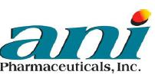
ANI Pharmaceuticals Reports Record Second Quarter 2026 Financial Results

•Quarterly net revenues of $266.0 million, an increase of 25.9% year-over-year
•Purified Cortrophin® Gel net revenues of $117.1 million, an increase of 43.5% year-over-year
•Quarterly GAAP net income available to common shareholders of $24.7 million; Quarterly adjusted non-GAAP EBITDA of $71.6 million, an increase of 32.4% year-over-year
•Diluted GAAP income per share of $1.05 and adjusted non-GAAP diluted earnings per share of $2.21
•Reaffirming 2026 guidance for total net revenue of $1,080 - $1,140 million and adjusted non-GAAP EBITDA of $285 - $300 million

PRINCETON, N.J., August 7, 2026 (GLOBE NEWSWIRE) -- ANI Pharmaceuticals, Inc. (Nasdaq: ANIP) (ANI or the Company) today announced financial results and business highlights for the second quarter ended June 30, 2026.

“In the second quarter, we delivered outstanding financial results, while we implemented the largest Rare Disease sales force expansion in our history,” said Nikhil Lalwani, President and CEO of ANI. “Leading indicators from our gout expansion for Cortrophin Gel are very positive, with the team rapidly delivering a large funnel of new patient cases, with significant breadth and depth of prescribing. The encouraging initial trends we are seeing from the gout expansion, and the continued momentum in our existing specialties, further support our conviction in Cortrophin Gel’s sizable multi-year growth opportunity.”

“We are reaffirming our full year 2026 total net revenue guidance of $1,080 - $1,140 million and adjusted non-GAAP EBITDA of $285 - $300 million. Based on our results in the first half of 2026, we are modestly adjusting our Cortrophin Gel net revenue guidance to $520 - $540 million, reflecting 50-55% growth for the full year. Our solid track record of commercial execution and prudent capital allocation combined with our strong balance sheet position us well for continued shareholder value creation,” he concluded.

Second Quarter and Recent Business Highlights:

Rare Disease
•Cortrophin Gel:
▪Cortrophin Gel net revenues were $117.1 million for the second quarter of 2026, an increase of 43.5% over the same period in 2025. Year-over-year growth in the second quarter of 2026 was driven primarily by the existing specialty areas of Nephrology, Neurology, Ophthalmology, Pulmonology and Rheumatology. Momentum for the existing specialties has continued into the third quarter with a record number of new cases initiated in July.
▪ANI’s organization expansion to reach podiatrists and primary care physicians for Cortrophin Gel in acute gouty arthritis flares was fully operational as of the end of June, as planned.
▪The Company’s key demand metrics of the gout expansion have been very positive to date, with over 95% of the reps generating multiple new patient cases and over a third of the prescribers initiating two or more cases, and the Company has seen balanced demand from both podiatrists and primary care physicians.
▪The gout expansion targets an estimated addressable market of approximately 285,000 patients, the majority of whom are treated by podiatrists and primary care physicians.

•ILUVIEN:
▪ILUVIEN® net revenues were $18.7 million for the second quarter of 2026, a decrease of 16.1% over the same period in 2025 based primarily on timing of international shipments.
▪The Company announced 6-month topline data from the Phase 4 open-label single-arm SYNCHRONICITY clinical trial in chronic non-infectious uveitis affecting the posterior segment of the eye (NIU-PS) and anticipates announcing the detailed results and additional analyses at a key medical conference attended by retina specialists in the fourth quarter of 2026.

Generics
•Generics net revenues were $99.1 million in the second quarter of 2026, an increase of 9.7% over the same period in 2025, driven by new product launches, including the partnered generic launch that commenced in the third quarter of 2025.
•Launched 12 new Generics products year-to-date, and on track for at least 15 new product launches in 2026.

Brand Royalties and Other Revenues
•The Company recognized $17.7 million of revenue under the Harmony Agreement, comprised of $9.7 million of royalties on net sales of pitolisant-based products for the second quarter of 2026, and $8.0 million based upon work completed in the quarter toward the achievement of certain development milestones. The balance of the development work is expected to be completed in the third quarter of 2026, at which time the Company will recognize an additional $2.0 million in development milestone revenue. In addition, the Company will continue to earn low single digit royalties on net sales of pitolisant-based products.

Brands
•Brands net revenues were $11.8 million for the second quarter of 2026, a decrease of 10.5% over the same period in 2025, reflecting a normalization in demand for certain products.

Corporate Highlights
•Effective on May 8, 2026, ANI’s board of directors authorized a share repurchase program to repurchase up to $100.0 million in common stock through May 2029.
Second Quarter 2026 Financial Results
 |  |  |  |  |  | Three Months Ended June 30,
(in thousands) |  |  |  |  |  | 2026 |  |  |  |  |  | 2025 |  |  |  |  |  | Change |  |  |  |  |  | % Change
Rare Disease and Brands
Cortrophin Gel |  |  |  |  |  | $ | 117,126 |  |  |  |  | $ | 81,647 |  |  |  |  | $ | 35,479 |  |  |  |  | 43.5 |  | %
ILUVIEN and YUTIQ (1) |  |  |  |  |  | 18,718 |  |  |  |  |  | 22,316 |  |  |  |  |  | (3,598) |  |  |  |  |  | (16.1) |  | %
Rare Disease total net revenues |  |  |  |  |  | $ | 135,844 |  |  |  |  | $ | 103,963 |  |  |  |  | $ | 31,881 |  |  |  |  | 30.7 |  | %
Brands |  |  |  |  |  | 11,813 |  |  |  |  |  | 13,195 |  |  |  |  |  | (1,382) |  |  |  |  |  | (10.5) |  | %
Brand royalties and other revenues |  |  |  |  |  | 17,731 |  |  |  |  |  | — |  |  |  |  |  | 17,731 |  |  |  |  |  | 100.0 |  | %
Rare Disease and Brands total net revenues |  |  |  |  |  | $ | 165,388 |  |  |  |  | $ | 117,158 |  |  |  |  | $ | 48,230 |  |  |  |  | 41.2 |  | %
Generics and Other
Generic pharmaceutical products |  |  |  |  |  | 99,051 |  |  |  |  |  | 90,297 |  |  |  |  |  | 8,754 |  |  |  |  |  | 9.7 |  | %
Other generic revenues |  |  |  |  |  | 1,605 |  |  |  |  |  | 3,916 |  |  |  |  |  | (2,311) |  |  |  |  |  | (59.0) |  | %
Generics and Other total net revenues |  |  |  |  |  | $ | 100,656 |  |  |  |  | $ | 94,213 |  |  |  |  | $ | 6,443 |  |  |  |  | 6.8 |  | %
Total net revenues |  |  |  |  |  | $ | 266,044 |  |  |  |  | $ | 211,371 |  |  |  |  | $ | 54,673 |  |  |  |  | 25.9 |  | %
(1) There were no sales of YUTIQ during the quarter ended June 30, 2026, as the Company transitioned promotional efforts in the U.S. from YUTIQ to ILUVIEN, which has a combined label of DME and NIU-PS during the second quarter of 2025.

All comparisons are made versus the same period in 2025 unless otherwise stated.

Total net revenues for the second quarter of 2026 were $266.0 million, an increase of 25.9% over the prior year period.

Net revenues for Rare Disease, which includes Cortrophin Gel and ILUVIEN, increased 30.7% to $135.8 million. Cortrophin Gel net revenues increased 43.5% to $117.1 million and ILUVIEN net revenues decreased 16.1% to $18.7 million. Growth for Cortrophin was driven primarily by increased volume while ILUVIEN was impacted by timing of shipments in certain international markets.

Net revenues for Brands decreased 10.5% to $11.8 million driven by normalization in demand for certain products.

Net revenues from Brand royalties and other revenues include $8.0 million of revenue recognized upon work completed in the quarter toward the achievement of certain development milestones and royalties of approximately $9.7 million, related to the Harmony Agreement.

Net revenues for Generic pharmaceutical products increased 9.7% to $99.1 million driven by continued strength in the partnered generic launch that commenced in the third quarter of 2025, contribution from new product launches and commercial and operational outperformance.

On a GAAP basis, gross margin decreased from 64.7% to 62.4%, while on a non-GAAP basis, gross margin decreased from 64.9% to 62.6%. Both decreases were primarily due to higher sales of royalty bearing products, including Cortrophin Gel and a partnered generic product that launched in the third quarter of 2025, and the non-recurrence of prior year revenues from Prucalopride. These effects were somewhat tempered by the revenue recognized under the Harmony Agreement.

On a GAAP basis and a non-GAAP basis, research and development expenses decreased 10.8% to $14.7 million and 11.4% to $14.1 million, respectively, driven by timing associated with ongoing and new projects to support future growth of our Rare Disease and Generics businesses.

On a GAAP basis, selling, general, and administrative expenses increased 12.1% to $91.7 million, while on a non-GAAP basis, selling, general, and administrative expenses increased 20.2% to $80.7 million. Both comparisons include incremental expense related to the initial marketing and recruitment expense of our expansion of the Rare Disease team, which is targeting opportunities in acute gouty arthritis, and an overall increase in activities to support the growth of our business.

On a GAAP basis, the Company reported net income attributable to common shareholders of $24.7 million, or $1.05 per diluted share, for the second quarter of 2026 compared to $8.1 million, or $0.36 per diluted share, in the prior year period. On a non-GAAP basis, the Company reported adjusted diluted earnings per share of $2.21 for the second quarter of 2026 compared to $1.80 in the prior year period.

Adjusted non-GAAP EBITDA for the second quarter of 2026 was $71.6 million, an increase of 32.4% from the second quarter of 2025, driven by increased net revenues and gross profit.

For reconciliations of adjusted non-GAAP metrics, including non-GAAP gross margin, non-GAAP research and development expenses, non-GAAP selling, general and administrative expenses, adjusted non-GAAP EBITDA and adjusted non-GAAP diluted earnings per share to the most directly comparable GAAP financial measures, please see Table 3, Table 4, and Table 5 below, respectively.

Liquidity

As of June 30, 2026, the Company had $360.2 million in unrestricted cash and cash equivalents, $274.5 million in net accounts receivable and $620.9 million in principal value of outstanding debt (inclusive of the Company’s senior convertible notes). The Company generated cash flow from operations of $115.0 million on a year to date basis.

Full Year 2026 Financial Guidance

 |  |  | Revised Full Year 2026  Guidance |  |  | Previous Full Year 2026 Guidance |  |  | 2025 Actual |  |  | Growth
Net Revenue (Total Company) |  |  | $1,080 million - $1,140 million |  |  | $1,080 million - $1,140 million |  |  | $883 million |  |  | 22% - 29%
Cortrophin Gel Net Revenue |  |  | $520 million - $540 million |  |  | $540 million - $575 million |  |  | $348 million |  |  | 50% - 55%
ILUVIEN Net Revenue |  |  | $78 million - $83 million |  |  | $78 million - $83 million |  |  | $75 million |  |  | 4% - 11%
Adjusted Non-GAAP EBITDA |  |  | $285 million - $300 million |  |  | $285 million - $300 million |  |  | $230 million |  |  | 24% - 31%
Adjusted Non-GAAP Diluted EPS |  |  | $9.19 - $9.69 |  |  | $9.19 - $9.69 |  |  | $7.89 |  |  | 16% - 23%
ANI expects full year total company adjusted non-GAAP gross margin between 59.9% and 60.9% and anticipates approximately 21.5 million and 21.8 million shares outstanding for the purpose of calculating full year adjusted non-GAAP diluted EPS. The Company expects its annual U.S. GAAP effective tax rate to be between 26% and 28% and will continue to tax effect non-GAAP adjustments for computation of adjusted non-GAAP diluted earnings per share utilizing a tax rate of 26%.

Conference Call

The Company’s management will host a conference call and webcast today, Friday, August 7, at 8:00 a.m. ET to discuss its second quarter 2026 results.

To view the webcast, please click here. Links to access the webcast and conference call will also be available on the “Events & Presentations” page of the Company’s website at https://www.anipharmaceuticals.com, under the “Investors” section. A replay of the event will remain accessible for up to one year.

Non-GAAP Financial Measures

Adjusted non-GAAP EBITDA

ANI’s management considers adjusted non-GAAP EBITDA to be an important financial indicator of ANI’s operating performance, providing investors and analysts with a useful measure of operating results unaffected by non-cash stock-based compensation and differences in capital structures, tax structures, capital investment cycles, ages of related assets, and compensation structures among otherwise comparable companies. Management uses adjusted non-GAAP EBITDA when analyzing Company performance.

Adjusted non-GAAP EBITDA is defined as net income, excluding tax expense, interest expense, net, other expense (income), net, depreciation and amortization expense, non-cash stock-based compensation expense, M&A transaction and integration expenses, contingent consideration fair value adjustments, unrealized gain (loss) on our investment in equity securities, expenses incurred and settlement payments received in connection with certain litigation matters, severance expenses, and certain other items that vary in frequency and impact on ANI’s results of operations. Adjusted non-GAAP EBITDA should be considered in addition to, but not in lieu of, net income or loss reported under GAAP. A reconciliation of adjusted non-GAAP EBITDA to the most directly comparable GAAP financial measure is provided below.

ANI is not providing a reconciliation for the forward-looking full year 2026 adjusted EBITDA guidance because it does not currently have sufficient information to accurately estimate all of the variables and individual adjustments for such reconciliation, including “with” and “without” tax provision information. As such, ANI’s management cannot estimate on a forward-looking basis without unreasonable effort the impact these variables and individual adjustments will have on its reported results.

Adjusted non-GAAP Net Income

ANI’s management considers adjusted non-GAAP net income to be an important financial indicator of ANI’s operating performance, providing investors and analysts with a useful measure of operating results unaffected by the non-cash stock-based compensation, non-cash interest expense, depreciation and amortization, M&A transaction and integration expenses, contingent consideration fair value adjustment, unrealized (gain) loss on our investment in equity securities, expenses incurred and settlement payments received in connection with certain litigation matters, severance expense, and certain other items that vary in frequency and impact on ANI’s results of operations. Management uses adjusted non-GAAP net income when analyzing Company performance.

Adjusted non-GAAP net income is defined as net income, plus the non-cash stock-based compensation, non-cash interest expense, depreciation and amortization, M&A transaction and integration expenses, contingent consideration fair value adjustment, unrealized (gain) loss on our investment in equity securities, expenses incurred and settlement payments received in connection with certain litigation matters, severance expense, and certain other items that vary in frequency and impact on ANI’s results of operations, less the tax impact of these adjustments calculated using an estimated statutory tax rate. Management will continually analyze this metric and may include additional adjustments in the calculation in order to provide further understanding of ANI’s results. Adjusted non-GAAP net income should be considered in addition to, but not in lieu of, net income reported under GAAP. A reconciliation of adjusted non-GAAP net income to the most directly comparable GAAP financial measure is provided below.

Adjusted non-GAAP Diluted Earnings per Share

ANI’s management considers adjusted non-GAAP diluted earnings per share to be an important financial indicator of ANI’s operating performance, providing investors and analysts with a useful measure of operating results unaffected by the non-cash stock-based compensation, non-cash interest expense, depreciation and amortization, M&A transaction and integration expenses, contingent consideration fair value adjustment, unrealized (gain) loss on our investment in equity securities, expenses incurred and settlement payments received in connection with certain litigation matters, severance expense, and certain other items that vary in frequency and impact on ANI’s results of operations. Management uses adjusted non-GAAP diluted earnings per share when analyzing Company performance.

Non-GAAP Adjusted Diluted Weighted-Average Shares Outstanding exclude certain dilutive shares related to the senior convertible notes as they are intended to be covered by our capped call transactions. Our outstanding capped call transactions are intended to fully offset the dilutive effect of the senior convertible notes recognized in the calculation of GAAP diluted EPS, and therefore 340,000 shares and 345,000 shares, for the three and six months ended June 30, 2026, respectively, have been excluded from the calculation of Non-GAAP Adjusted Diluted Weighted-Average Shares Outstanding.

Adjusted non-GAAP diluted earnings per share is defined as adjusted non-GAAP net income, as defined above, divided by the diluted weighted average shares outstanding during the period. Management will continually analyze this metric and may include additional adjustments in the calculation in order to provide further understanding of ANI’s results. Adjusted non-GAAP diluted earnings per share should be considered in addition to, but not in lieu of, diluted earnings (loss) per share reported under GAAP. A reconciliation of adjusted non-GAAP diluted earnings per share to the most directly comparable GAAP financial measure is provided below.

ANI is not providing a reconciliation for the forward-looking full year 2026 adjusted diluted earnings per share guidance because it does not currently have sufficient information to accurately estimate all of the variables and individual adjustments for such reconciliation, including “with” and “without” tax provision information. As such, ANI’s management cannot estimate on a forward-looking basis without unreasonable effort the impact these variables and individual adjustments will have on its reported results.

Other non-GAAP metrics

ANI’s management considers non-GAAP research and development expenses and non-GAAP selling, general, and administrative expenses to be financial indicators of ANI’s operating performance, providing investors and analysts with useful measures of operating results unaffected by non-cash stock-based compensation expense, M&A transaction and integration expenses, expenses incurred and settlement payments received in connection with certain litigation matters, severance expense, and certain other items that vary in frequency and impact on ANI’s results of operations.

Management uses adjusted non-GAAP research and development expenses and non-GAAP selling, general, and administrative expenses when analyzing Company performance. Non-GAAP research and development expenses is defined as research and development expenses, excluding non-cash stock-based compensation expense, and certain other items that vary in frequency and impact on ANI’s results of operations.

Non-GAAP selling, general, and administrative expenses is defined as selling, general, and administrative expenses, excluding non-cash stock-based compensation expense, M&A transaction and integration expenses, expenses incurred and settlement payments received in connection with certain litigation matters, severance expense, and certain other items that vary in frequency and impact on ANI’s results of operations.

Each of adjusted non-GAAP research and development expenses and non-GAAP selling, general, and administrative expenses should be considered in addition to, but not in lieu of, research and development expenses, and selling, general, and administrative expenses reported under GAAP, respectively.

A reconciliation of each of non-GAAP research and development expenses and non-GAAP selling, general and administrative expenses to the most directly comparable GAAP financial measure is provided below.

ANI’s management also considers non-GAAP gross margin to be a financial indicator of ANI’s operating performance, providing investors and analysts with a useful measure of operating results unaffected by non-cash stock-based compensation expense, and certain other items that vary in frequency and impact on ANI’s results of operations. Management uses non-GAAP gross margin when analyzing Company performance.

Non-GAAP gross margin is defined as adjusted non-GAAP net revenues less non-GAAP cost of sales (excluding depreciation and amortization) divided by non-GAAP net revenues. Non-GAAP gross margin should be considered in addition to, but not in lieu of, gross margin reported under GAAP.

About ANI

ANI Pharmaceuticals, Inc. (Nasdaq: ANIP) is a diversified biopharmaceutical company committed to its mission of “Serving Patients, Improving Lives” by developing, manufacturing, and commercializing innovative and high-quality therapeutics. The Company is focused on delivering sustainable growth through its Rare Disease business, which markets novel products in the areas of ophthalmology, rheumatology, nephrology, neurology, and pulmonology; its Generics business, which leverages R&D expertise, operational excellence, and U.S.-based manufacturing; and its Brands business. For more information, visit https://www.anipharmaceuticals.com/.

Forward-Looking Statements

To the extent any statements made in this release deal with information that is not historical, these are forward-looking statements within the meaning of the Private Securities Litigation Reform Act of 1995. Such statements include, but are not limited to, statements regarding the Company’s strategy; its expectations regarding its future operations, financial position or revenues, including its 2026 financial guidance; its expectations regarding its share repurchase program; the results and timing of the Company’s preclinical studies, clinical trials, regulatory submissions and regulatory approvals; the commercialization and anticipated sales of the Company’s products, including current and planned product launches and any additional product launches from the Company’s generic pipeline; the Company’s estimates of the market opportunity and addressable patient populations for its products; the expansion and execution capabilities of the Company’s sales force for acute gouty arthritis for Cortrophin Gel; the Company’s anticipated growth opportunities, including for Cortrophin Gel and ILUVIEN; the Company’s positioning for continued shareholder value creation; anticipated R&D developments and clinical trial advances; and other statements that are not historical in nature, particularly those that utilize terminology such as “anticipates,” “will,” “expects,” “plans,” “potential,” “future,” “believes,” “intends,” “continue,” the negatives thereof, or other words of similar meaning, derivations of such words and the use of future dates.

Uncertainties and risks may cause the Company’s actual results to be materially different than those expressed in or implied by such forward-looking statements. Uncertainties and risks include, but are not limited to: the ability of the Company’s approved products, including Cortrophin Gel and ILUVIEN, to achieve commercialization at levels of market acceptance that will allow the Company to maintain profitability; the Company’s ability to complete or achieve any or all of the intended benefits of acquisitions and investments, in a timely manner or at all; delays and disruptions in the production of the Company’s approved products; increased costs and potential loss of revenues if the Company needs to change suppliers due to the limited number of suppliers for its raw materials, active pharmaceutical ingredients, excipients, and other materials; delays and disruptions in the production of the Company’s approved products as a result of its reliance on single source third party contract manufacturing supply for certain of its key products, including Cortrophin Gel and ILUVIEN; delays or failure to obtain or maintain approvals by the FDA of the Company’s products; changes in policy or actions that may be taken by the FDA, United States Drug Enforcement Administration and other regulatory agencies; risks that the Company may face with respect to importing raw materials and delays in delivery of raw materials and other ingredients and supplies necessary for the manufacture of the Company’s products from both domestic and overseas sources due to supply chain disruptions or for any other reason, including increased costs due to tariffs or macroeconomic disruptions; the ability of the Company’s manufacturing partners to meet its product demands and timelines; the impact of changes or fluctuations in exchange rates; the Company’s ability to develop, license or acquire, and commercialize new products; the Company’s obligations in agreements under which it licenses, develops or commercializes rights to products or technology from third parties and its ability to maintain such licenses; the level of competition the Company faces and the legal, regulatory and/or legislative strategies employed by its competitors to prevent or delay competition from generic alternatives to branded products; the Company’s ability to protect its intellectual property rights; the impact of legislative or regulatory reform on the pricing for pharmaceutical products; the impact of any litigation to which the Company is, or may become, a party; the Company’s ability, and that of its suppliers, development partners, and manufacturing partners, to comply with laws, regulations and standards that govern or affect the pharmaceutical and biotechnology industries; the Company’s ability to maintain the services of its key executives and other personnel; and general business and economic conditions, such as inflationary pressures, geopolitical conditions.

More detailed information on these and additional factors that could affect the Company’s actual results are described in the Company’s filings with the Securities and Exchange Commission (SEC), including its most recent annual report on Form 10-K and quarterly reports on Form 10-Q, and other periodic reports, as well as other filings with the SEC. All forward-looking statements in this news release speak only as of the date of this news release and are based on the Company’s current beliefs, assumptions, and expectations. The Company undertakes no obligation to update or revise any forward-looking statement, whether as a result of new information, future events or otherwise.

Investor Relations:
Irina Koffler, Vice President, Investor Relations
T: 917-734-7387
E: Irina.koffler@anipharmaceuticals.com

Media Relations:
Argot Partners
T: 212-600-1494
E: ani@argotpartners.com

SOURCE: ANI Pharmaceuticals, Inc.

FINANCIAL TABLES FOLLOW

ANI Pharmaceuticals, Inc. and Subsidiaries
Table 1: US GAAP Statements of Operations
(unaudited, in thousands, except per share amounts)

 |  |  | Three Months Ended June 30, |  |  |  |  |  |  |  |  |  |  |  | Six Months Ended June 30,
 |  |  | 2026 |  |  |  |  |  | 2025 |  |  |  |  |  | 2026 |  |  |  |  |  | 2025
Net Revenues |  |  | $ | 266,044 |  |  |  |  | $ | 211,371 |  |  |  |  | $ | 503,506 |  |  |  |  | $ | 408,493
Operating Expenses
Cost of sales (excluding depreciation and amortization) |  |  | 100,158 |  |  |  |  |  | 74,615 |  |  |  |  |  | 193,740 |  |  |  |  |  | 147,652
Research and development |  |  | 14,747 |  |  |  |  |  | 16,535 |  |  |  |  |  | 25,347 |  |  |  |  |  | 27,099
Selling, general, and administrative |  |  | 91,661 |  |  |  |  |  | 81,771 |  |  |  |  |  | 165,316 |  |  |  |  |  | 158,299
Depreciation and amortization |  |  | 19,640 |  |  |  |  |  | 23,281 |  |  |  |  |  | 40,559 |  |  |  |  |  | 46,172
Contingent consideration fair value adjustment |  |  | (622) |  |  |  |  |  | 1,277 |  |  |  |  |  | (804) |  |  |  |  |  | (10,815)
Total Operating Expenses, net |  |  | 225,584 |  |  |  |  |  | 197,479 |  |  |  |  |  | 424,158 |  |  |  |  |  | 368,407
Operating income |  |  | 40,460 |  |  |  |  |  | 13,892 |  |  |  |  |  | 79,348 |  |  |  |  |  | 40,086
Other (expense) income, net
Unrealized gain (loss) on investment in equity securities |  |  | 741 |  |  |  |  |  | 332 |  |  |  |  |  | 6,494 |  |  |  |  |  | (589)
Interest expense, net |  |  | (3,636) |  |  |  |  |  | (5,438) |  |  |  |  |  | (7,405) |  |  |  |  |  | (10,922)
Other (expense) income, net |  |  | (468) |  |  |  |  |  | 1,739 |  |  |  |  |  | (1,119) |  |  |  |  |  | 1,937
Income Before Income Tax Expense |  |  | 37,097 |  |  |  |  |  | 10,525 |  |  |  |  |  | 77,318 |  |  |  |  |  | 30,512
Income tax expense |  |  | 12,386 |  |  |  |  |  | 1,976 |  |  |  |  |  | 23,115 |  |  |  |  |  | 6,282
Net Income |  |  | $ | 24,711 |  |  |  |  | $ | 8,549 |  |  |  |  | $ | 54,203 |  |  |  |  | $ | 24,230
Dividends on Series A Convertible Preferred Stock |  |  | — |  |  |  |  |  | (407) |  |  |  |  |  | — |  |  |  |  |  | (813)
Net Income Available to Common Shareholders |  |  | $ | 24,711 |  |  |  |  | $ | 8,142 |  |  |  |  | $ | 54,203 |  |  |  |  | $ | 23,417
Basic and Diluted Income Per Share:
Basic Income Per Share |  |  | $ | 1.09 |  |  |  |  | $ | 0.37 |  |  |  |  | $ | 2.40 |  |  |  |  | $ | 1.07
Diluted Income Per Share |  |  | $ | 1.05 |  |  |  |  | $ | 0.36 |  |  |  |  | $ | 2.32 |  |  |  |  | $ | 1.05
Basic Weighted-Average Shares Outstanding |  |  | 21,158 |  |  |  |  |  | 19,834 |  |  |  |  |  | 21,036 |  |  |  |  |  | 19,721
Diluted Weighted-Average Shares Outstanding |  |  | 21,915 |  |  |  |  |  | 20,308 |  |  |  |  |  | 21,785 |  |  |  |  |  | 20,177

ANI Pharmaceuticals, Inc. and Subsidiaries
Table 2: US GAAP Balance Sheets
(unaudited, in thousands)
 |  |  | June 30,  2026 |  |  |  |  |  | December 31,  2025
Assets
Current Assets
Cash and cash equivalents |  |  | $ | 360,212 |  |  |  |  | $ | 285,585
Restricted cash |  |  | 35 |  |  |  |  |  | 36
Accounts receivable, net |  |  | 274,469 |  |  |  |  |  | 281,082
Inventories |  |  | 143,149 |  |  |  |  |  | 143,067
Prepaid expenses and other current assets |  |  | 31,942 |  |  |  |  |  | 34,216
Investment in equity securities |  |  | 15,626 |  |  |  |  |  | 9,131
Total Current Assets |  |  | 825,433 |  |  |  |  |  | 753,117
Non-current Assets
Property and equipment, net |  |  | 73,223 |  |  |  |  |  | 62,476
Deferred tax assets, net |  |  | 71,495 |  |  |  |  |  | 69,072
Intangible assets, net |  |  | 449,857 |  |  |  |  |  | 479,526
Goodwill |  |  | 62,480 |  |  |  |  |  | 62,480
Other non-current assets |  |  | 11,624 |  |  |  |  |  | 13,706
Total Assets |  |  | $ | 1,494,112 |  |  |  |  | $ | 1,440,377
Liabilities and Stockholders’ Equity
Current Liabilities
Accounts payable |  |  | $ | 73,830 |  |  |  |  | $ | 62,583
Accrued royalties |  |  | 55,830 |  |  |  |  |  | 48,497
Accrued compensation and related expenses |  |  | 27,154 |  |  |  |  |  | 37,897
Accrued government rebates |  |  | 41,392 |  |  |  |  |  | 43,154
Returned goods reserve |  |  | 44,013 |  |  |  |  |  | 49,504
Accrued expenses and other |  |  | 16,575 |  |  |  |  |  | 16,970
Income taxes payable |  |  | 3,532 |  |  |  |  |  | 2,239
Current debt, net |  |  | 21,329 |  |  |  |  |  | 17,268
Total Current Liabilities |  |  | 283,655 |  |  |  |  |  | 278,112
Non-current Liabilities
Debt, net |  |  | 280,155 |  |  |  |  |  | 291,840
Convertible notes, net |  |  | 309,009 |  |  |  |  |  | 307,927
Contingent consideration |  |  | 8,546 |  |  |  |  |  | 9,610
Other non-current liabilities |  |  | 15,535 |  |  |  |  |  | 12,164
Total Liabilities |  |  | $ | 896,900 |  |  |  |  | $ | 899,653
Stockholders’ Equity
Common Stock |  |  | 3 |  |  |  |  |  | 3
Class C Special Stock |  |  | — |  |  |  |  |  | —
Preferred Stock |  |  | — |  |  |  |  |  | —
Treasury stock |  |  | (53,817) |  |  |  |  |  | (33,249)
Additional paid-in capital |  |  | 620,249 |  |  |  |  |  | 596,036
Retained earnings (Accumulated deficit) |  |  | 31,104 |  |  |  |  |  | (23,099)
Accumulated other comprehensive (loss) income, net of tax |  |  | (327) |  |  |  |  |  | 1,033
Total Stockholders’ Equity |  |  | 597,212 |  |  |  |  |  | 540,724
Total Liabilities and Stockholders’ Equity |  |  | $ | 1,494,112 |  |  |  |  | $ | 1,440,377

ANI Pharmaceuticals, Inc. and Subsidiaries
Table 3: Adjusted non-GAAP EBITDA Calculation and US GAAP to Non-GAAP Reconciliation
(unaudited, in thousands)
 |  |  |  |  |  |  |  |  |  |  |  |  |  |  |  |  |  |  |  |  |  |  |  | Reconciliation of certain adjusted non-GAAP accounts:
 |  |  |  |  |  |  |  |  |  |  |  |  |  |  |  |  |  |  |  |  |  |  |  | Net Revenues |  |  |  |  |  |  |  |  |  |  |  | Cost of sales (excluding depreciation and amortization) |  |  |  |  |  |  |  |  |  |  |  | Selling, general, and administrative |  |  |  |  |  |  |  |  |  |  |  | Research and development
 |  |  |  |  |  | Three Months Ended June 30, |  |  |  |  |  |  |  |  |  |  |  |  |  |  |  |  |  | Three Months Ended June 30, |  |  |  |  |  |  |  |  |  |  |  | Three Months Ended June 30, |  |  |  |  |  |  |  |  |  |  |  | Three Months Ended June 30, |  |  |  |  |  |  |  |  |  |  |  | Three Months Ended June 30,
 |  |  |  |  |  | 2026 |  |  |  |  |  | 2025 |  |  |  |  |  |  |  |  |  |  |  | 2026 |  |  |  |  |  | 2025 |  |  |  |  |  | 2026 |  |  |  |  |  | 2025 |  |  |  |  |  | 2026 |  |  |  |  |  | 2025 |  |  |  |  |  | 2026 |  |  |  |  |  | 2025
Net Income |  |  |  |  |  | $ | 24,711 |  |  |  |  | $ | 8,549 |  |  |  |  | As reported: |  |  |  |  |  | $ | 266,044 |  |  |  |  | $ | 211,371 |  |  |  |  | $ | 100,158 |  |  |  |  | $ | 74,615 |  |  |  |  | $ | 91,661 |  |  |  |  | $ | 81,771 |  |  |  |  | $ | 14,747 |  |  |  |  | $ | 16,535
Add/(Subtract):
Interest expense, net |  |  |  |  |  | 3,636 |  |  |  |  |  | 5,438
Other expense (income), net |  |  |  |  |  | 468 |  |  |  |  |  | (1,739)
Income tax expense |  |  |  |  |  | 12,386 |  |  |  |  |  | 1,976
Depreciation and amortization |  |  |  |  |  | 19,640 |  |  |  |  |  | 23,281
Contingent consideration fair value adjustment |  |  |  |  |  | (622) |  |  |  |  |  | 1,277
Unrealized gain on investment in equity securities |  |  |  |  |  | (741) |  |  |  |  |  | (332)
Stock-based compensation |  |  |  |  |  | 11,406 |  |  |  |  |  | 9,603 |  |  |  |  |  | Stock-based compensation |  |  |  |  |  | — |  |  |  |  |  | — |  |  |  |  |  | (552) |  |  |  |  |  | (405) |  |  |  |  |  | (10,238) |  |  |  |  |  | (8,615) |  |  |  |  |  | (616) |  |  |  |  |  | (583)
M&A transaction and integration expenses |  |  |  |  |  | 40 |  |  |  |  |  | 823 |  |  |  |  |  | M&A transaction and integration expenses |  |  |  |  |  | — |  |  |  |  |  | — |  |  |  |  |  | — |  |  |  |  |  | — |  |  |  |  |  | (40) |  |  |  |  |  | (823) |  |  |  |  |  | — |  |  |  |  |  | —
Litigation expenses |  |  |  |  |  | 673 |  |  |  |  |  | 5,201 |  |  |  |  |  | Litigation expenses |  |  |  |  |  | — |  |  |  |  |  | — |  |  |  |  |  | — |  |  |  |  |  | — |  |  |  |  |  | (673) |  |  |  |  |  | (5,201) |  |  |  |  |  | — |  |  |  |  |  | —
Adjusted non-GAAP EBITDA |  |  |  |  |  | $ | 71,597 |  |  |  |  | $ | 54,077 |  |  |  |  | As adjusted: |  |  |  |  |  | $ | 266,044 |  |  |  |  | $ | 211,371 |  |  |  |  | $ | 99,606 |  |  |  |  | $ | 74,210 |  |  |  |  | $ | 80,710 |  |  |  |  | $ | 67,132 |  |  |  |  | $ | 14,131 |  |  |  |  | $ | 15,952

 |  |  |  |  |  |  |  |  |  |  |  |  |  |  |  |  |  |  |  |  |  |  |  | Reconciliation of certain adjusted non-GAAP accounts:
 |  |  |  |  |  |  |  |  |  |  |  |  |  |  |  |  |  |  |  |  |  |  |  | Net Revenues |  |  |  |  |  |  |  |  |  |  |  | Cost of sales (excluding depreciation and amortization) |  |  |  |  |  |  |  |  |  |  |  | Selling, general, and administrative |  |  |  |  |  |  |  |  |  |  |  | Research and development
 |  |  |  |  |  | Six Months Ended June 30, |  |  |  |  |  |  |  |  |  |  |  |  |  |  |  |  |  | Six Months Ended June 30, |  |  |  |  |  |  |  |  |  |  |  | Six Months Ended June 30, |  |  |  |  |  |  |  |  |  |  |  | Six Months Ended June 30, |  |  |  |  |  |  |  |  |  |  |  | Six Months Ended June 30,
 |  |  |  |  |  | 2026 |  |  |  |  |  | 2025 |  |  |  |  |  |  |  |  |  |  |  | 2026 |  |  |  |  |  | 2025 |  |  |  |  |  | 2026 |  |  |  |  |  | 2025 |  |  |  |  |  | 2026 |  |  |  |  |  | 2025 |  |  |  |  |  | 2026 |  |  |  |  |  | 2025
Net Income |  |  |  |  |  | $ | 54,203 |  |  |  |  | $ | 24,230 |  |  |  |  | As reported: |  |  |  |  |  | $ | 503,506 |  |  |  |  | $ | 408,493 |  |  |  |  | $ | 193,740 |  |  |  |  | $ | 147,652 |  |  |  |  | $ | 165,316 |  |  |  |  | $ | 158,299 |  |  |  |  | $ | 25,347 |  |  |  |  | $ | 27,099
Add/(Subtract):
Interest expense, net |  |  |  |  |  | 7,405 |  |  |  |  |  | 10,922
Other expense (income), net |  |  |  |  |  | 1,119 |  |  |  |  |  | (1,937)
Income tax expense |  |  |  |  |  | 23,115 |  |  |  |  |  | 6,282
Depreciation and amortization |  |  |  |  |  | 40,559 |  |  |  |  |  | 46,172
Contingent consideration fair value adjustment |  |  |  |  |  | (804) |  |  |  |  |  | (10,815)
Unrealized (gain) loss on investment in equity securities |  |  |  |  |  | (6,494) |  |  |  |  |  | 589
Stock-based compensation |  |  |  |  |  | 21,597 |  |  |  |  |  | 18,470 |  |  |  |  |  | Stock-based compensation |  |  |  |  |  | — |  |  |  |  |  | — |  |  |  |  |  | (1,047) |  |  |  |  |  | (780) |  |  |  |  |  | (19,310) |  |  |  |  |  | (16,581) |  |  |  |  |  | (1,240) |  |  |  |  |  | (1,109)
M&A transaction and integration expenses |  |  |  |  |  | 301 |  |  |  |  |  | 2,617 |  |  |  |  |  | M&A transaction and integration expenses |  |  |  |  |  | — |  |  |  |  |  | — |  |  |  |  |  | — |  |  |  |  |  | — |  |  |  |  |  | (301) |  |  |  |  |  | (2,617) |  |  |  |  |  | — |  |  |  |  |  | —
Litigation expenses and settlement proceeds |  |  |  |  |  | (6,407) |  |  |  |  |  | 8,192 |  |  |  |  |  | Litigation expenses and settlement proceeds |  |  |  |  |  | — |  |  |  |  |  | — |  |  |  |  |  | — |  |  |  |  |  | — |  |  |  |  |  | 6,407 |  |  |  |  |  | (8,192) |  |  |  |  |  | — |  |  |  |  |  | —
Severance |  |  |  |  |  | — |  |  |  |  |  | 105 |  |  |  |  |  | Severance |  |  |  |  |  | — |  |  |  |  |  | — |  |  |  |  |  | — |  |  |  |  |  | — |  |  |  |  |  | — |  |  |  |  |  | (105) |  |  |  |  |  | — |  |  |  |  |  | —
Adjusted non-GAAP EBITDA |  |  |  |  |  | $ | 134,594 |  |  |  |  | $ | 104,827 |  |  |  |  | As adjusted: |  |  |  |  |  | $ | 503,506 |  |  |  |  | $ | 408,493 |  |  |  |  | $ | 192,693 |  |  |  |  | $ | 146,872 |  |  |  |  | $ | 152,112 |  |  |  |  | $ | 130,804 |  |  |  |  | $ | 24,107 |  |  |  |  | $ | 25,990

ANI Pharmaceuticals, Inc. and Subsidiaries
Table 4: US GAAP Gross Margin to Non-GAAP Gross Margin Reconciliation
(unaudited, in thousands)

 |  |  |  |  |  | Three Months Ended June 30, |  |  |  |  |  |  |  |  |  |  |  | Six Months Ended June 30,
 |  |  |  |  |  | 2026 |  |  |  |  |  | 2025 |  |  |  |  |  | 2026 |  |  |  |  |  | 2025
GAAP net revenues |  |  |  |  |  | $ | 266,044 |  |  |  |  | $ | 211,371 |  |  |  |  | $ | 503,506 |  |  |  |  | $ | 408,493
GAAP cost of sales (excluding depreciation and amortization) |  |  |  |  |  | 100,158 |  |  |  |  |  | 74,615 |  |  |  |  |  | 193,740 |  |  |  |  |  | 147,652
GAAP gross profit |  |  |  |  |  | $ | 165,886 |  |  |  |  | $ | 136,756 |  |  |  |  | $ | 309,766 |  |  |  |  | $ | 260,841
Stock-based compensation |  |  |  |  |  | 552 |  |  |  |  |  | 405 |  |  |  |  |  | 1,047 |  |  |  |  |  | 780
Non-GAAP gross profit |  |  |  |  |  | $ | 166,438 |  |  |  |  | $ | 137,161 |  |  |  |  | $ | 310,813 |  |  |  |  | $ | 261,621
GAAP gross margin |  |  |  |  |  | 62.4 |  | % |  |  |  | 64.7 |  | % |  |  |  | 61.5 |  | % |  |  |  | 63.9 |  | %
Non-GAAP gross margin |  |  |  |  |  | 62.6 |  | % |  |  |  | 64.9 |  | % |  |  |  | 61.7 |  | % |  |  |  | 64.0 |  | %

ANI Pharmaceuticals, Inc. and Subsidiaries
Table 5: Adjusted non-GAAP Net Income and Adjusted non-GAAP Diluted Earnings per Share Reconciliation
(unaudited, in thousands, except per share amounts)

 |  |  | Three Months Ended June 30, |  |  |  |  |  |  |  |  |  |  |  | Six Months Ended June 30,
 |  |  | 2026 |  |  |  |  |  | 2025 |  |  |  |  |  | 2026 |  |  |  |  |  | 2025
Net Income Available to Common Shareholders |  |  | $ | 24,711 |  |  |  |  | $ | 8,142 |  |  |  |  | $ | 54,203 |  |  |  |  | $ | 23,417
Add/(Subtract):
Non-cash interest expense |  |  | 137 |  |  |  |  |  | 252 |  |  |  |  |  | 354 |  |  |  |  |  | 511
Depreciation and amortization |  |  | 19,640 |  |  |  |  |  | 23,281 |  |  |  |  |  | 40,559 |  |  |  |  |  | 46,172
Contingent consideration fair value adjustment |  |  | (622) |  |  |  |  |  | 1,277 |  |  |  |  |  | (804) |  |  |  |  |  | (10,815)
Unrealized (gain) loss on investment in equity securities |  |  | (741) |  |  |  |  |  | (332) |  |  |  |  |  | (6,494) |  |  |  |  |  | 589
Stock-based compensation |  |  | 11,406 |  |  |  |  |  | 9,603 |  |  |  |  |  | 21,597 |  |  |  |  |  | 18,470
M&A transaction and integration expenses |  |  | 40 |  |  |  |  |  | 823 |  |  |  |  |  | 301 |  |  |  |  |  | 2,617
Litigation expenses and settlement proceeds |  |  | 673 |  |  |  |  |  | 5,201 |  |  |  |  |  | (6,407) |  |  |  |  |  | 8,192
Severance |  |  | — |  |  |  |  |  | — |  |  |  |  |  | — |  |  |  |  |  | 105
Other expense (income) |  |  | 442 |  |  |  |  |  | (1,773) |  |  |  |  |  | 1,104 |  |  |  |  |  | (2,009)
Less:
Estimated tax impact of adjustments |  |  | (8,054) |  |  |  |  |  | (9,966) |  |  |  |  |  | (13,055) |  |  |  |  |  | (16,596)
Adjusted non-GAAP Net Income Available to Common Shareholders (1) |  |  | $ | 47,632 |  |  |  |  | $ | 36,508 |  |  |  |  | $ | 91,358 |  |  |  |  | $ | 70,653
Diluted Weighted-Average
Shares Outstanding |  |  | 21,915 |  |  |  |  |  | 20,308 |  |  |  |  |  | 21,785 |  |  |  |  |  | 20,177
Adjusted Diluted Weighted-Average (2)
Shares Outstanding |  |  | 21,575 |  |  |  |  |  | 20,308 |  |  |  |  |  | 21,440 |  |  |  |  |  | 20,177
Adjusted non-GAAP
Diluted Earnings per Share |  |  | $ | 2.21 |  |  |  |  | $ | 1.80 |  |  |  |  | $ | 4.26 |  |  |  |  | $ | 3.50

(1) Adjusted non-GAAP Net Income Available to Common Shareholders excludes undistributed earnings to participating securities.
(2) Non-GAAP Adjusted Diluted Weighted-Average Shares Outstanding exclude certain dilutive shares related to the senior convertible notes as they are intended to be covered by our capped call transactions. Our outstanding capped call transactions are intended to fully offset the dilutive effect of the senior convertible notes recognized in the calculation of GAAP diluted EPS, and therefore 340,000 shares and 345,000 shares, for the three and six months ended June 30, 2026, respectively, have been excluded from the calculation of Non-GAAP Adjusted Diluted Weighted-Average Shares Outstanding.


© 2026 ANI Pharmaceuticals, Inc. 1 Corporate Presentation August 2026

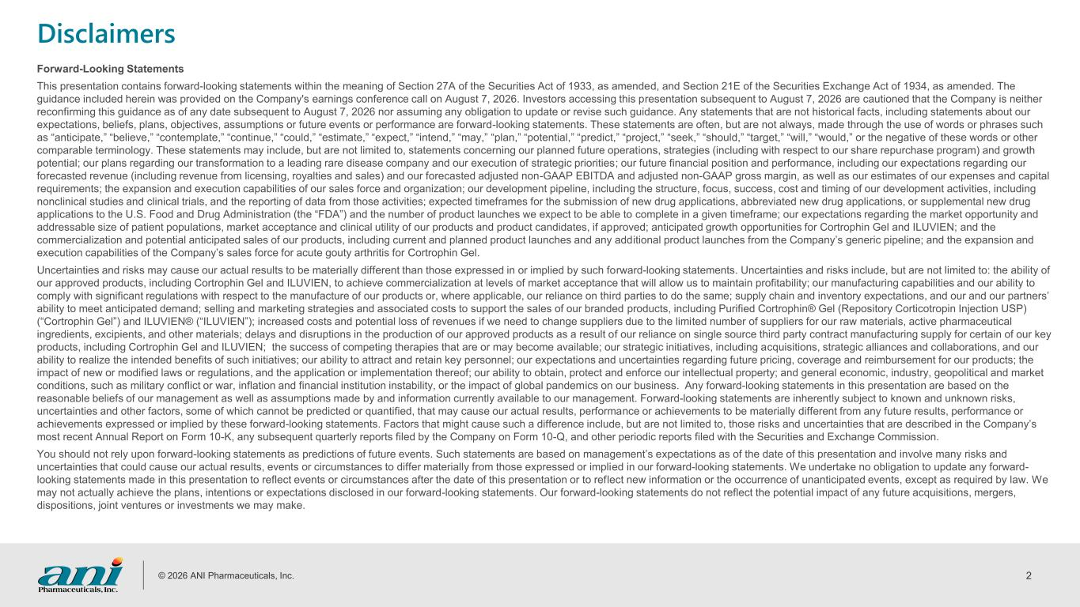
© 2026 ANI Pharmaceuticals, Inc. 2 Disclaimers Forward-Looking Statements This presentation contains forward-looking statements within the meaning of Section 27A of the Securities Act of 1933, as amended, and Section 21E of the Securities Exchange Act of 1934, as amended. The guidance included herein was provided on the Company's earnings conference call on August 7, 2026. Investors accessing this presentation subsequent to August 7, 2026 are cautioned that the Company is neither reconfirming this guidance as of any date subsequent to August 7, 2026 nor assuming any obligation to update or revise such guidance. Any statements that are not historical facts, including statements about our expectations, beliefs, plans, objectives, assumptions or future events or performance are forward-looking statements. These statements are often, but are not always, made through the use of words or phrases such as “anticipate,” “believe,” “contemplate,” “continue,” “could,” “estimate,” “expect,” “intend,” “may,” “plan,” “potential,” “predict,” “project,” “seek,” “should,” “target,” “will,” “would,” or the negative of these words or other comparable terminology. These statements may include, but are not limited to, statements concerning our planned future operations, strategies (including with respect to our share repurchase program) and growth potential; our plans regarding our transformation to a leading rare disease company and our execution of strategic priorities; our future financial position and performance, including our expectations regarding our forecasted revenue (including revenue from licensing, royalties and sales) and our forecasted adjusted non-GAAP EBITDA and adjusted non-GAAP gross margin, as well as our estimates of our expenses and capital requirements; the expansion and execution capabilities of our sales force and organization; our development pipeline, including the structure, focus, success, cost and timing of our development activities, including nonclinical studies and clinical trials, and the reporting of data from those activities; expected timeframes for the submission of new drug applications, abbreviated new drug applications, or supplemental new drug applications to the U.S. Food and Drug Administration (the “FDA”) and the number of product launches we expect to be able to complete in a given timeframe; our expectations regarding the market opportunity and addressable size of patient populations, market acceptance and clinical utility of our products and product candidates, if approved; anticipated growth opportunities for Cortrophin Gel and ILUVIEN; and the commercialization and potential anticipated sales of our products, including current and planned product launches and any additional product launches from the Company’s generic pipeline; and the expansion and execution capabilities of the Company’s sales force for acute gouty arthritis for Cortrophin Gel. Uncertainties and risks may cause our actual results to be materially different than those expressed in or implied by such forward-looking statements. Uncertainties and risks include, but are not limited to: the ability of our approved products, including Cortrophin Gel and ILUVIEN, to achieve commercialization at levels of market acceptance that will allow us to maintain profitability; our manufacturing capabilities and our ability to comply with significant regulations with respect to the manufacture of our products or, where applicable, our reliance on third parties to do the same; supply chain and inventory expectations, and our and our partners’ ability to meet anticipated demand; selling and marketing strategies and associated costs to support the sales of our branded products, including Purified Cortrophin® Gel (Repository Corticotropin Injection USP) (“Cortrophin Gel”) and ILUVIEN® (“ILUVIEN”); increased costs and potential loss of revenues if we need to change suppliers due to the limited number of suppliers for our raw materials, active pharmaceutical ingredients, excipients, and other materials; delays and disruptions in the production of our approved products as a result of our reliance on single source third party contract manufacturing supply for certain of our key products, including Cortrophin Gel and ILUVIEN; the success of competing therapies that are or may become available; our strategic initiatives, including acquisitions, strategic alliances and collaborations, and our ability to realize the intended benefits of such initiatives; our ability to attract and retain key personnel; our expectations and uncertainties regarding future pricing, coverage and reimbursement for our products; the impact of new or modified laws or regulations, and the application or implementation thereof; our ability to obtain, protect and enforce our intellectual property; and general economic, industry, geopolitical and market conditions, such as military conflict or war, inflation and financial institution instability, or the impact of global pandemics on our business. Any forward-looking statements in this presentation are based on the reasonable beliefs of our management as well as assumptions made by and information currently available to our management. Forward-looking statements are inherently subject to known and unknown risks, uncertainties and other factors, some of which cannot be predicted or quantified, that may cause our actual results, performance or achievements to be materially different from any future results, performance or achievements expressed or implied by these forward-looking statements. Factors that might cause such a difference include, but are not limited to, those risks and uncertainties that are described in the Company’s most recent Annual Report on Form 10-K, any subsequent quarterly reports filed by the Company on Form 10-Q, and other periodic reports filed with the Securities and Exchange Commission. You should not rely upon forward-looking statements as predictions of future events. Such statements are based on management’s expectations as of the date of this presentation and involve many risks and uncertainties that could cause our actual results, events or circumstances to differ materially from those expressed or implied in our forward-looking statements. We undertake no obligation to update any forward- looking statements made in this presentation to reflect events or circumstances after the date of this presentation or to reflect new information or the occurrence of unanticipated events, except as required by law. We may not actually achieve the plans, intentions or expectations disclosed in our forward-looking statements. Our forward-looking statements do not reflect the potential impact of any future acquisitions, mergers, dispositions, joint ventures or investments we may make.

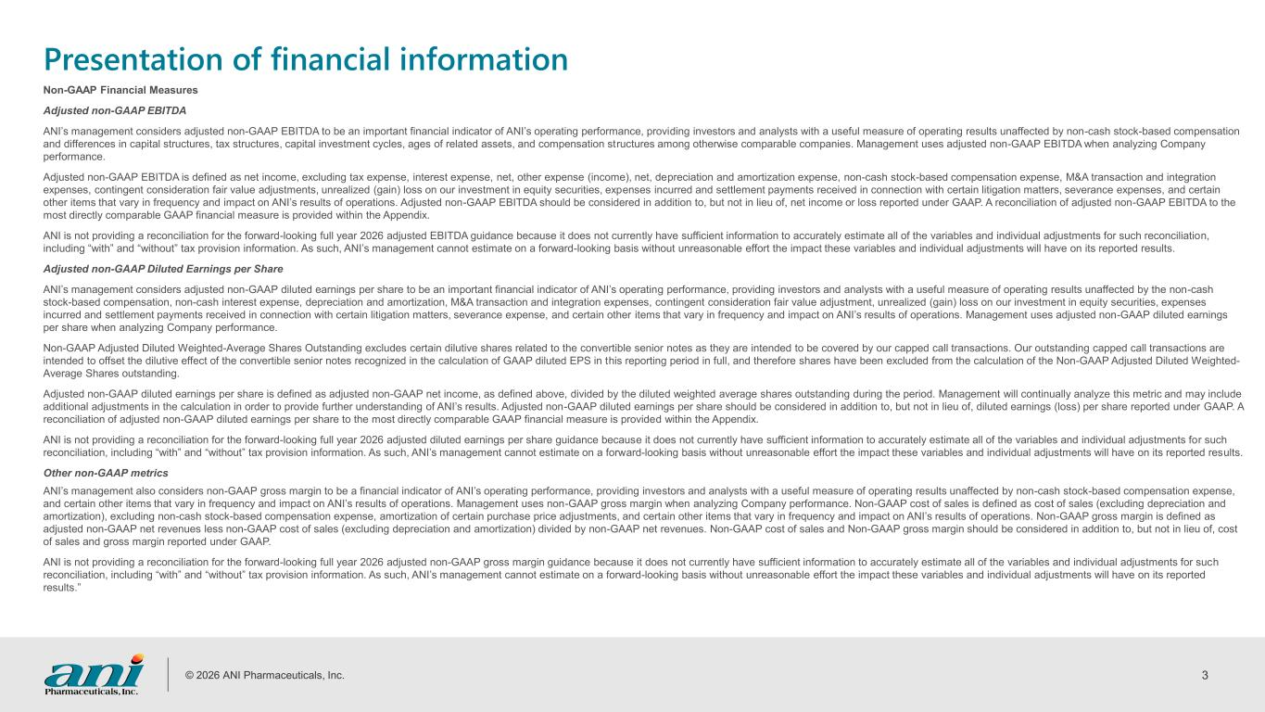
© 2026 ANI Pharmaceuticals, Inc. 3 Presentation of financial information Non-GAAP Financial Measures Adjusted non-GAAP EBITDA ANI’s management considers adjusted non-GAAP EBITDA to be an important financial indicator of ANI’s operating performance, providing investors and analysts with a useful measure of operating results unaffected by non-cash stock-based compensation and differences in capital structures, tax structures, capital investment cycles, ages of related assets, and compensation structures among otherwise comparable companies. Management uses adjusted non-GAAP EBITDA when analyzing Company performance. Adjusted non-GAAP EBITDA is defined as net income, excluding tax expense, interest expense, net, other expense (income), net, depreciation and amortization expense, non-cash stock-based compensation expense, M&A transaction and integration expenses, contingent consideration fair value adjustments, unrealized (gain) loss on our investment in equity securities, expenses incurred and settlement payments received in connection with certain litigation matters, severance expenses, and certain other items that vary in frequency and impact on ANI’s results of operations. Adjusted non-GAAP EBITDA should be considered in addition to, but not in lieu of, net income or loss reported under GAAP. A reconciliation of adjusted non-GAAP EBITDA to the most directly comparable GAAP financial measure is provided within the Appendix. ANI is not providing a reconciliation for the forward-looking full year 2026 adjusted EBITDA guidance because it does not currently have sufficient information to accurately estimate all of the variables and individual adjustments for such reconciliation, including “with” and “without” tax provision information. As such, ANI’s management cannot estimate on a forward-looking basis without unreasonable effort the impact these variables and individual adjustments will have on its reported results. Adjusted non-GAAP Diluted Earnings per Share ANI’s management considers adjusted non-GAAP diluted earnings per share to be an important financial indicator of ANI’s operating performance, providing investors and analysts with a useful measure of operating results unaffected by the non-cash stock-based compensation, non-cash interest expense, depreciation and amortization, M&A transaction and integration expenses, contingent consideration fair value adjustment, unrealized (gain) loss on our investment in equity securities, expenses incurred and settlement payments received in connection with certain litigation matters, severance expense, and certain other items that vary in frequency and impact on ANI’s results of operations. Management uses adjusted non-GAAP diluted earnings per share when analyzing Company performance. Non-GAAP Adjusted Diluted Weighted-Average Shares Outstanding excludes certain dilutive shares related to the convertible senior notes as they are intended to be covered by our capped call transactions. Our outstanding capped call transactions are intended to offset the dilutive effect of the convertible senior notes recognized in the calculation of GAAP diluted EPS in this reporting period in full, and therefore shares have been excluded from the calculation of the Non-GAAP Adjusted Diluted Weighted- Average Shares outstanding. Adjusted non-GAAP diluted earnings per share is defined as adjusted non-GAAP net income, as defined above, divided by the diluted weighted average shares outstanding during the period. Management will continually analyze this metric and may include additional adjustments in the calculation in order to provide further understanding of ANI’s results. Adjusted non-GAAP diluted earnings per share should be considered in addition to, but not in lieu of, diluted earnings (loss) per share reported under GAAP. A reconciliation of adjusted non-GAAP diluted earnings per share to the most directly comparable GAAP financial measure is provided within the Appendix. ANI is not providing a reconciliation for the forward-looking full year 2026 adjusted diluted earnings per share guidance because it does not currently have sufficient information to accurately estimate all of the variables and individual adjustments for such reconciliation, including “with” and “without” tax provision information. As such, ANI’s management cannot estimate on a forward-looking basis without unreasonable effort the impact these variables and individual adjustments will have on its reported results. Other non-GAAP metrics ANI’s management also considers non-GAAP gross margin to be a financial indicator of ANI’s operating performance, providing investors and analysts with a useful measure of operating results unaffected by non-cash stock-based compensation expense, and certain other items that vary in frequency and impact on ANI’s results of operations. Management uses non-GAAP gross margin when analyzing Company performance. Non-GAAP cost of sales is defined as cost of sales (excluding depreciation and amortization), excluding non-cash stock-based compensation expense, amortization of certain purchase price adjustments, and certain other items that vary in frequency and impact on ANI’s results of operations. Non-GAAP gross margin is defined as adjusted non-GAAP net revenues less non-GAAP cost of sales (excluding depreciation and amortization) divided by non-GAAP net revenues. Non-GAAP cost of sales and Non-GAAP gross margin should be considered in addition to, but not in lieu of, cost of sales and gross margin reported under GAAP. ANI is not providing a reconciliation for the forward-looking full year 2026 adjusted non-GAAP gross margin guidance because it does not currently have sufficient information to accurately estimate all of the variables and individual adjustments for such reconciliation, including “with” and “without” tax provision information. As such, ANI’s management cannot estimate on a forward-looking basis without unreasonable effort the impact these variables and individual adjustments will have on its reported results.”

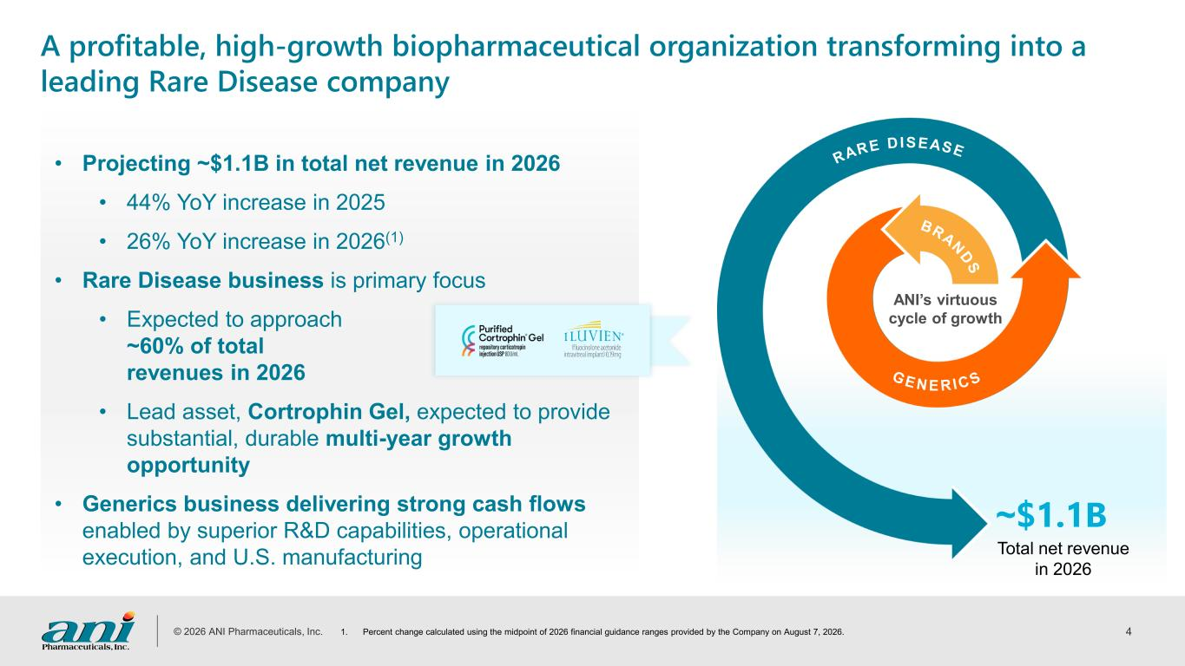
© 2026 ANI Pharmaceuticals, Inc. 4 ~$1.1B Total net revenue in 2026 A profitable, high-growth biopharmaceutical organization transforming into a leading Rare Disease company • Projecting ~$1.1B in total net revenue in 2026 • 44% YoY increase in 2025 • 26% YoY increase in 2026(1) • Rare Disease business is primary focus • Expected to approach ~60% of total revenues in 2026 • Lead asset, Cortrophin Gel, expected to provide substantial, durable multi-year growth opportunity • Generics business delivering strong cash flows enabled by superior R&D capabilities, operational execution, and U.S. manufacturing 1. Percent change calculated using the midpoint of 2026 financial guidance ranges provided by the Company on August 7, 2026. RARE DISEASE BRA N D S G E N E R I C S ANI’s virtuous cycle of growth

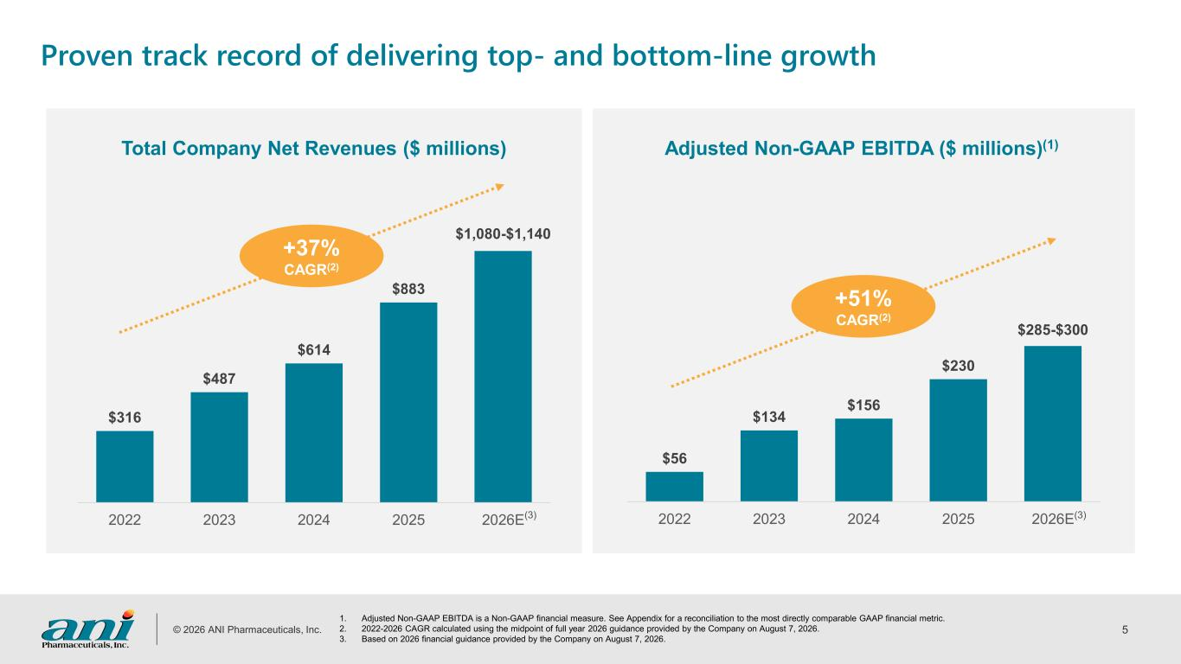
© 2026 ANI Pharmaceuticals, Inc. 5 Proven track record of delivering top- and bottom-line growth​ Adjusted Non-GAAP EBITDA ($ millions)(1)Total Company Net Revenues ($ millions) 1. Adjusted Non-GAAP EBITDA is a Non-GAAP financial measure. See Appendix for a reconciliation to the most directly comparable GAAP financial metric. 2. 2022-2026 CAGR calculated using the midpoint of full year 2026 guidance provided by the Company on August 7, 2026. 3. Based on 2026 financial guidance provided by the Company on August 7, 2026. $316 $487 $614 $883 $1,080-$1,140 2022 2023 2024 2025 2026E +37% CAGR(2) $56 $134 $156 $230 $285-$300 2022 2023 2024 2025 2026E +51% CAGR(2) (3) (3)

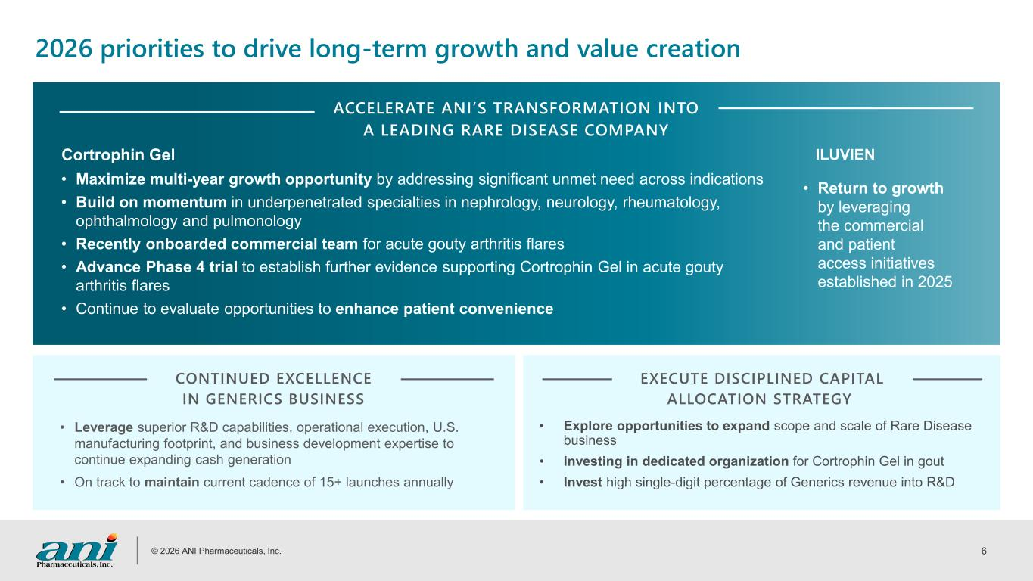
© 2026 ANI Pharmaceuticals, Inc. 6 ACCELERATE ANI’S TRANSFORMATION INTO A LEADING RARE DISEASE COMPANY Cortrophin Gel 2026 priorities to drive long-term growth and value creation • Maximize multi-year growth opportunity by addressing significant unmet need across indications • Build on momentum in underpenetrated specialties in nephrology, neurology, rheumatology, ophthalmology and pulmonology • Recently onboarded commercial team for acute gouty arthritis flares • Advance Phase 4 trial to establish further evidence supporting Cortrophin Gel in acute gouty arthritis flares • Continue to evaluate opportunities to enhance patient convenience ILUVIEN • Return to growth by leveraging the commercial and patient access initiatives established in 2025 CONTINUED EXCELLENCE IN GENERICS BUSINESS EXECUTE DISCIPLINED CAPITAL ALLOCATION STRATEGY • Leverage superior R&D capabilities, operational execution, U.S. manufacturing footprint, and business development expertise to continue expanding cash generation • On track to maintain current cadence of 15+ launches annually • Explore opportunities to expand scope and scale of Rare Disease business • Investing in dedicated organization for Cortrophin Gel in gout • Invest high single-digit percentage of Generics revenue into R&D

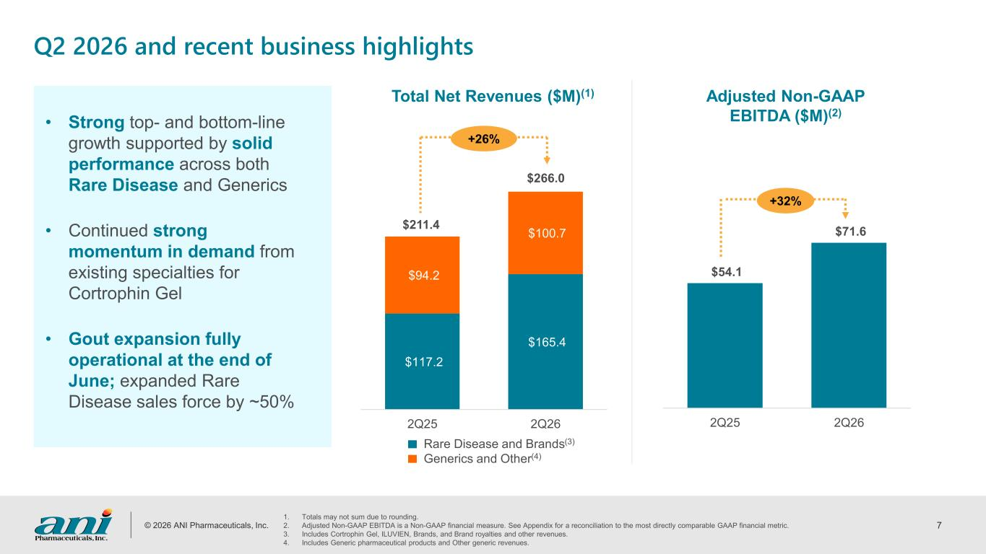
© 2026 ANI Pharmaceuticals, Inc. 7 Q2 2026 and recent business highlights 1. Totals may not sum due to rounding. 2. Adjusted Non-GAAP EBITDA is a Non-GAAP financial measure. See Appendix for a reconciliation to the most directly comparable GAAP financial metric. 3. Includes Cortrophin Gel, ILUVIEN, Brands, and Brand royalties and other revenues. 4. Includes Generic pharmaceutical products and Other generic revenues. • Strong top- and bottom-line growth supported by solid performance across both Rare Disease and Generics • Continued strong momentum in demand from existing specialties for Cortrophin Gel • Gout expansion fully operational at the end of June; expanded Rare Disease sales force by ~50% $117.2 $165.4 $94.2 $100.7 2Q25 2Q26 +26% $211.4 $266.0 $54.1 $71.6 2Q25 2Q26 Adjusted Non-GAAP EBITDA ($M)(2) +32% Total Net Revenues ($M)(1) Rare Disease and Brands(3) Generics and Other(4)

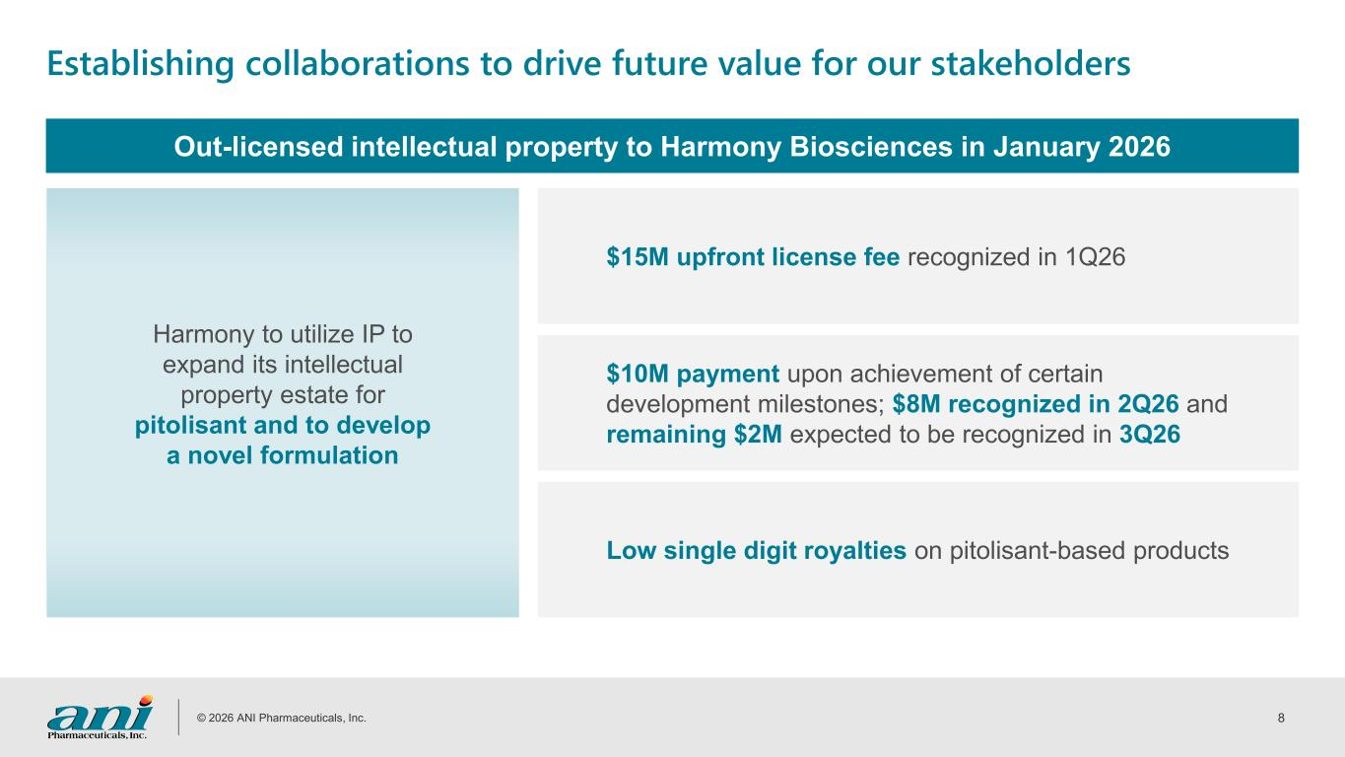
© 2026 ANI Pharmaceuticals, Inc. 8 Establishing collaborations to drive future value for our stakeholders Out-licensed intellectual property to Harmony Biosciences in January 2026 Harmony to utilize IP to expand its intellectual property estate for pitolisant and to develop a novel formulation Low single digit royalties on pitolisant-based products $10M payment upon achievement of certain development milestones; $8M recognized in 2Q26 and remaining $2M expected to be recognized in 3Q26 $15M upfront license fee recognized in 1Q26

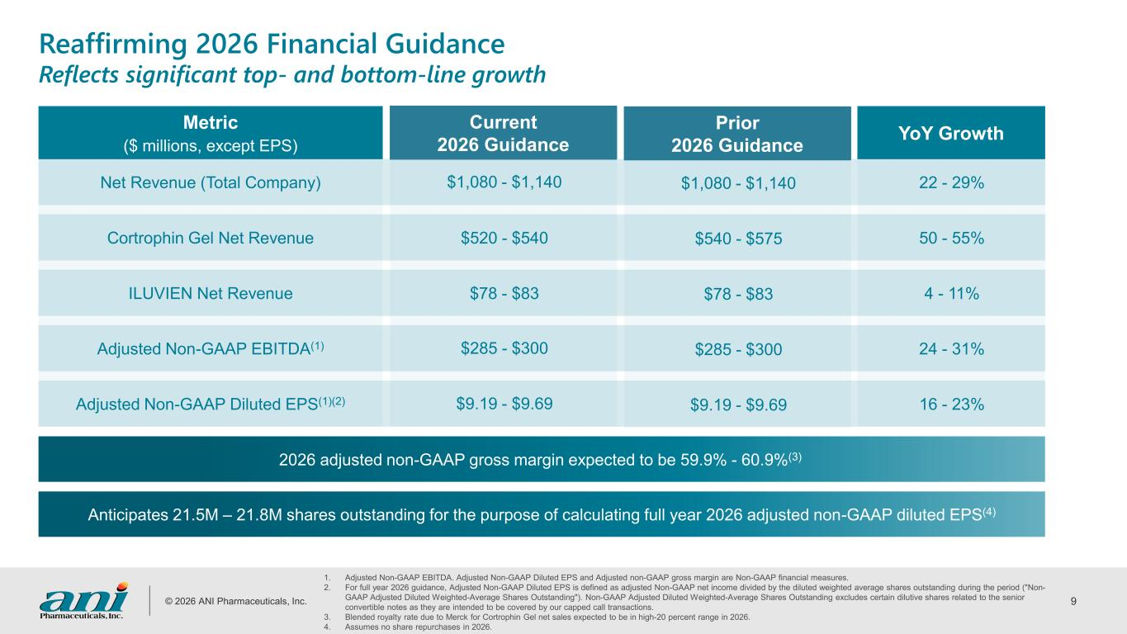
© 2026 ANI Pharmaceuticals, Inc. 9 1. Adjusted Non-GAAP EBITDA. Adjusted Non-GAAP Diluted EPS and Adjusted non-GAAP gross margin are Non-GAAP financial measures. 2. For full year 2026 guidance, Adjusted Non-GAAP Diluted EPS is defined as adjusted Non-GAAP net income divided by the diluted weighted average shares outstanding during the period ("Non- GAAP Adjusted Diluted Weighted-Average Shares Outstanding"). Non-GAAP Adjusted Diluted Weighted-Average Shares Outstanding excludes certain dilutive shares related to the senior convertible notes as they are intended to be covered by our capped call transactions. 3. Blended royalty rate due to Merck for Cortrophin Gel net sales expected to be in high-20 percent range in 2026. 4. Assumes no share repurchases in 2026. YoY Growth $1,080 - $1,140 22 - 29% $520 - $540 50 - 55% $78 - $83 4 - 11% $285 - $300 24 - 31% $9.19 - $9.69 16 - 23% Metric ($ millions, except EPS) Net Revenue (Total Company) Cortrophin Gel Net Revenue ILUVIEN Net Revenue Adjusted Non-GAAP EBITDA(1) Adjusted Non-GAAP Diluted EPS(1)(2) Current 2026 Guidance Reaffirming 2026 Financial Guidance Reflects significant top- and bottom-line growth 2026 adjusted non-GAAP gross margin expected to be 59.9% - 60.9%(3) $1,080 - $1,140 $540 - $575 $78 - $83 $285 - $300 $9.19 - $9.69 Prior 2026 Guidance Anticipates 21.5M – 21.8M shares outstanding for the purpose of calculating full year 2026 adjusted non-GAAP diluted EPS(4)

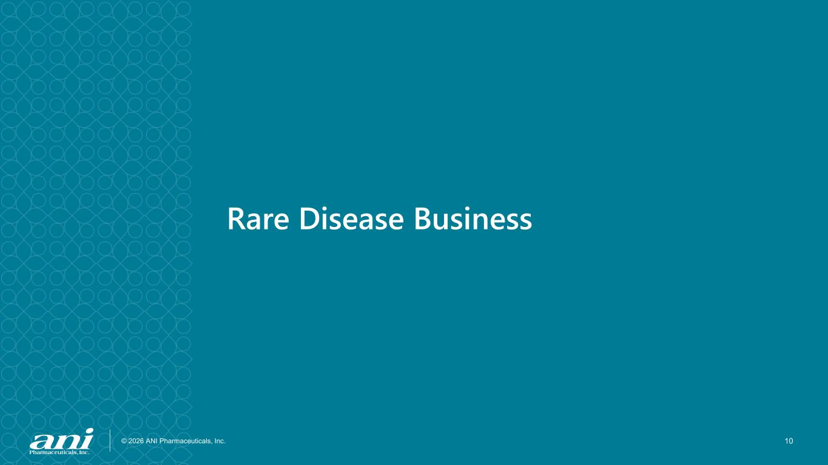
© 2026 ANI Pharmaceuticals, Inc. 10 Rare Disease Business

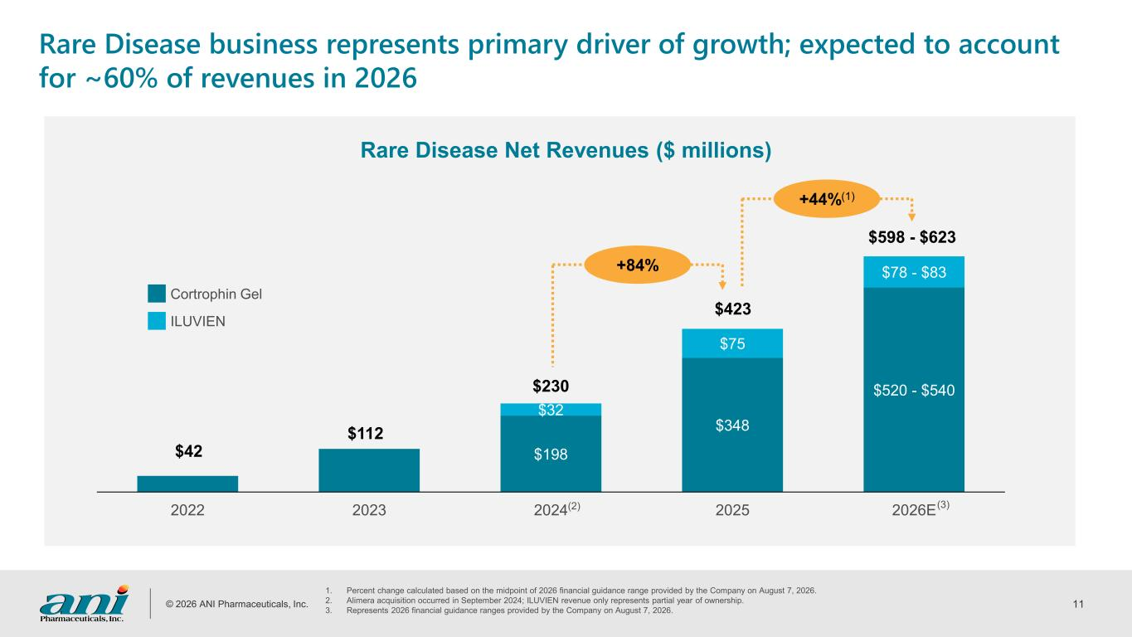
© 2026 ANI Pharmaceuticals, Inc. 11 Rare Disease business represents primary driver of growth; expected to account for ~60% of revenues in 2026 1. Percent change calculated based on the midpoint of 2026 financial guidance range provided by the Company on August 7, 2026. 2. Alimera acquisition occurred in September 2024; ILUVIEN revenue only represents partial year of ownership. 3. Represents 2026 financial guidance ranges provided by the Company on August 7, 2026. Rare Disease Net Revenues ($ millions) $198 $348 $520 - $540 $32 $75 $78 - $83 2022 2023 2024 2025 2026E $230 $423 $42 $112 $598 - $623 (3) Cortrophin Gel ILUVIEN +84% +44%(1) (2)

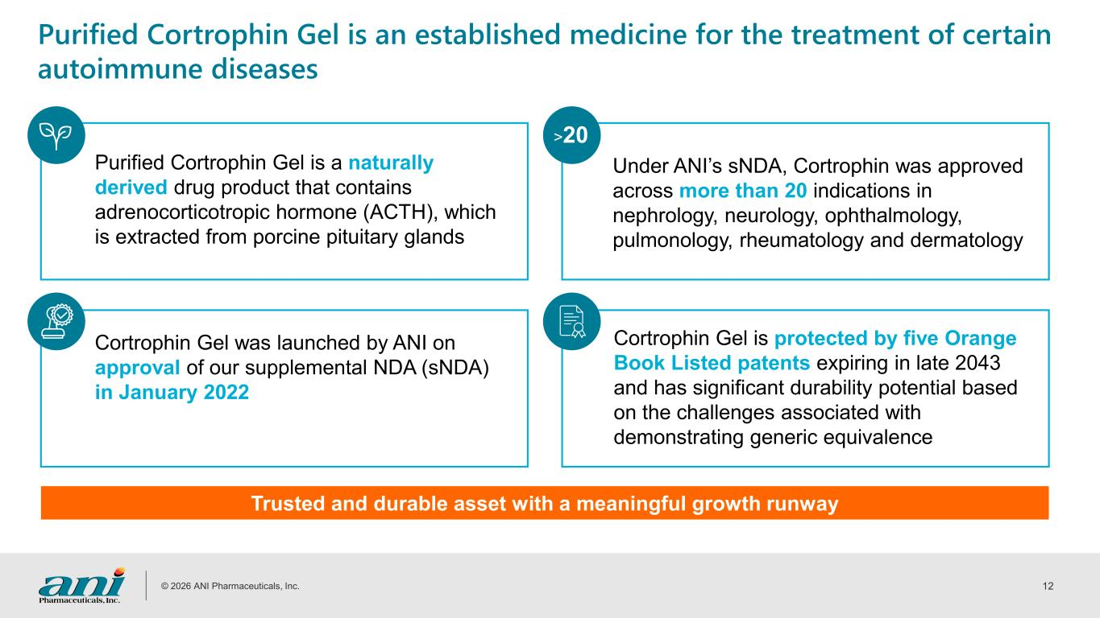
© 2026 ANI Pharmaceuticals, Inc. 12 Purified Cortrophin Gel is an established medicine for the treatment of certain autoimmune diseases Purified Cortrophin Gel is a naturally derived drug product that contains adrenocorticotropic hormone (ACTH), which is extracted from porcine pituitary glands Trusted and durable asset with a meaningful growth runway Cortrophin Gel was launched by ANI on approval of our supplemental NDA (sNDA) in January 2022 Under ANI’s sNDA, Cortrophin was approved across more than 20 indications in nephrology, neurology, ophthalmology, pulmonology, rheumatology and dermatology Cortrophin Gel is protected by five Orange Book Listed patents expiring in late 2043 and has significant durability potential based on the challenges associated with demonstrating generic equivalence >20

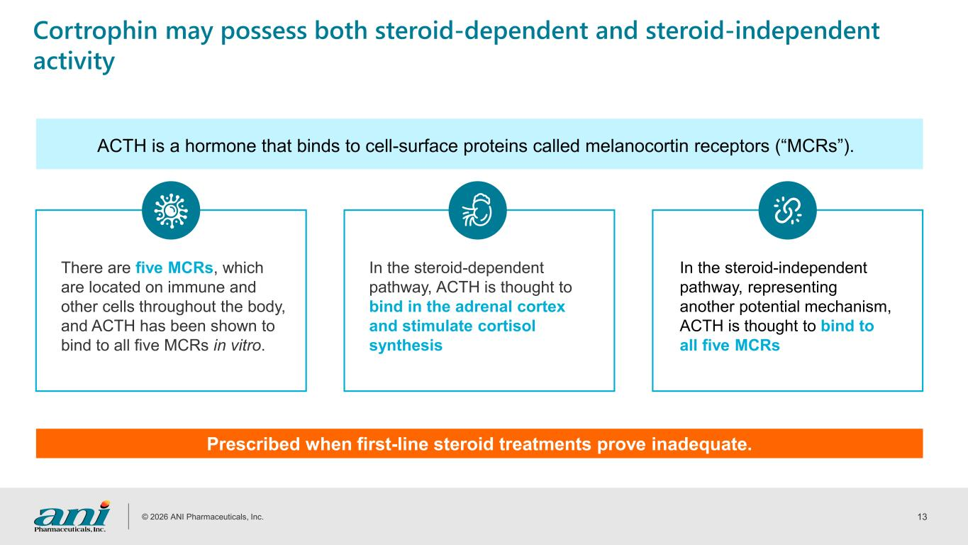
© 2026 ANI Pharmaceuticals, Inc. 13 Cortrophin may possess both steroid-dependent and steroid-independent activity In the steroid-independent pathway, representing another potential mechanism, ACTH is thought to bind to all five MCRs ACTH is a hormone that binds to cell-surface proteins called melanocortin receptors (“MCRs”). Prescribed when first-line steroid treatments prove inadequate. There are five MCRs, which are located on immune and other cells throughout the body, and ACTH has been shown to bind to all five MCRs in vitro. In the steroid-dependent pathway, ACTH is thought to bind in the adrenal cortex and stimulate cortisol synthesis

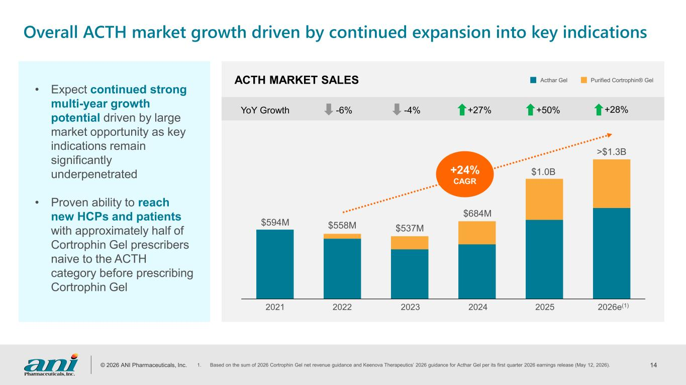
© 2026 ANI Pharmaceuticals, Inc. 14 2021 2022 2023 2024 2025 $594M $558M $537M $684M $1.0B ACTH MARKET SALES -6% -4% +27%YoY Growth +50% Acthar Gel Purified Cortrophin® Gel >$1.3B +28% 2026e(1) Overall ACTH market growth driven by continued expansion into key indications • Expect continued strong multi-year growth potential driven by large market opportunity as key indications remain significantly underpenetrated • Proven ability to reach new HCPs and patients with approximately half of Cortrophin Gel prescribers naive to the ACTH category before prescribing Cortrophin Gel 1. Based on the sum of 2026 Cortrophin Gel net revenue guidance and Keenova Therapeutics’ 2026 guidance for Acthar Gel per its first quarter 2026 earnings release (May 12, 2026). +24% CAGR

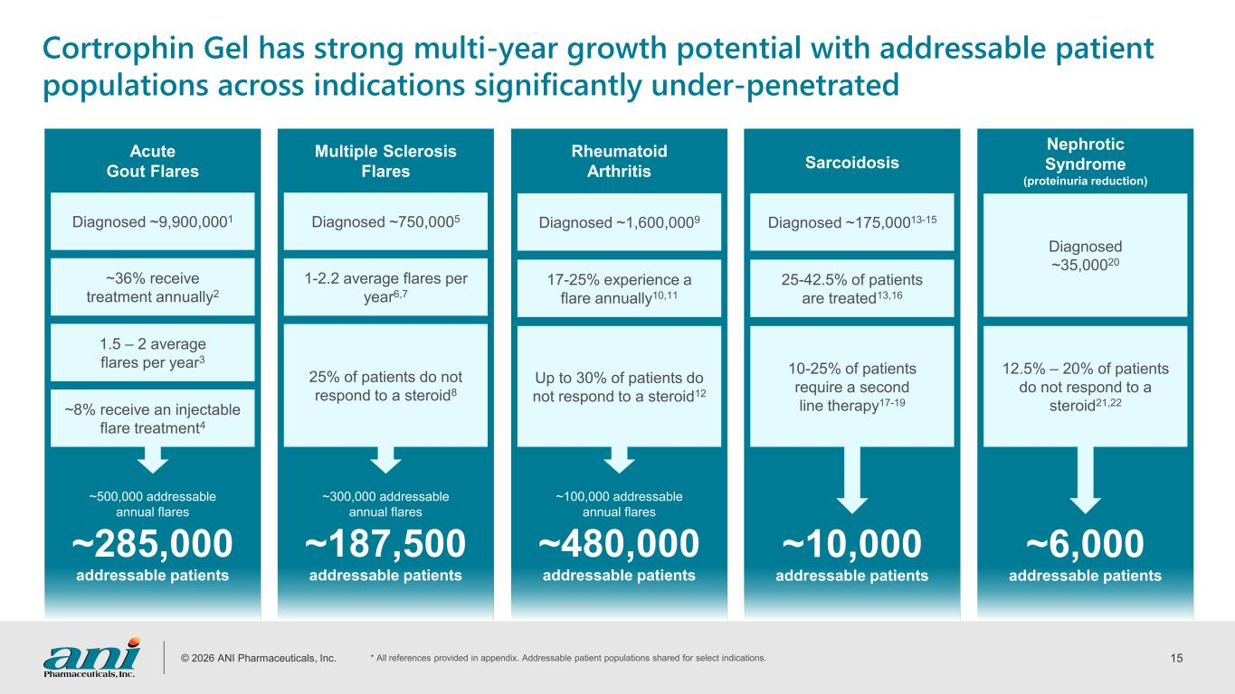
© 2026 ANI Pharmaceuticals, Inc. 15 Diagnosed ~9,900,0001 ~500,000 addressable annual flares ~285,000 addressable patients Acute Gout Flares Cortrophin Gel has strong multi-year growth potential with addressable patient populations across indications significantly under-penetrated ~36% receive treatment annually2 1.5 – 2 average flares per year3 ~8% receive an injectable flare treatment4 Diagnosed ~750,0005 Multiple Sclerosis Flares 1-2.2 average flares per year6,7 25% of patients do not respond to a steroid8 Diagnosed ~1,600,0009 Rheumatoid Arthritis 17-25% experience a flare annually10,11 Up to 30% of patients do not respond to a steroid12 Diagnosed ~35,00020 Nephrotic Syndrome (proteinuria reduction) 12.5% – 20% of patients do not respond to a steroid21,22 Diagnosed ~175,00013-15 Sarcoidosis 25-42.5% of patients are treated13,16 10-25% of patients require a second line therapy17-19 ~300,000 addressable annual flares ~187,500 addressable patients ~100,000 addressable annual flares ~480,000 addressable patients ~10,000 addressable patients ~6,000 addressable patients * All references provided in appendix. Addressable patient populations shared for select indications.

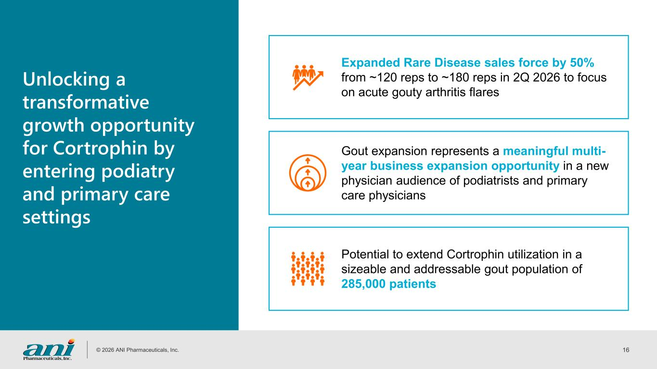
© 2026 ANI Pharmaceuticals, Inc. 16 Unlocking a transformative growth opportunity for Cortrophin by entering podiatry and primary care settings Gout expansion represents a meaningful multi- year business expansion opportunity in a new physician audience of podiatrists and primary care physicians Potential to extend Cortrophin utilization in a sizeable and addressable gout population of 285,000 patients Expanded Rare Disease sales force by 50% from ~120 reps to ~180 reps in 2Q 2026 to focus on acute gouty arthritis flares

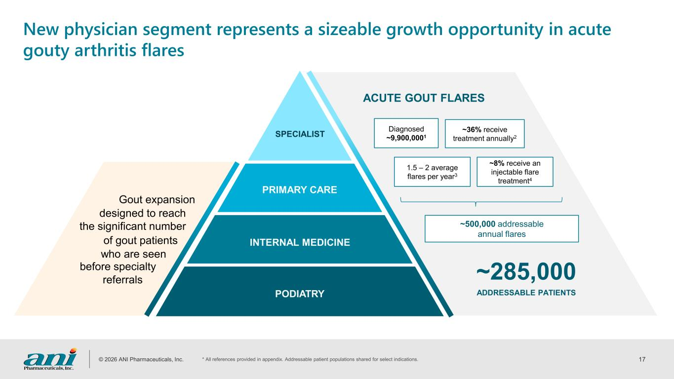
© 2026 ANI Pharmaceuticals, Inc. 17 New physician segment represents a sizeable growth opportunity in acute gouty arthritis flares PRIMARY CARE INTERNAL MEDICINE PODIATRY SPECIALIST Diagnosed ~9,900,0001 ACUTE GOUT FLARES ~36% receive treatment annually2 1.5 – 2 average flares per year3 ~8% receive an injectable flare treatment4 ~285,000 ADDRESSABLE PATIENTS Gout expansion designed to reach the significant number of gout patients who are seen referrals before specialty ~500,000 addressable annual flares * All references provided in appendix. Addressable patient populations shared for select indications.

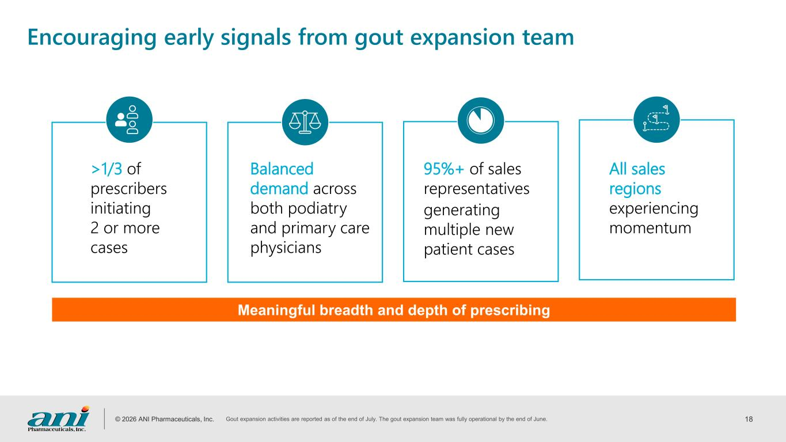
© 2026 ANI Pharmaceuticals, Inc. 18 Encouraging early signals from gout expansion team >1/3 of prescribers initiating 2 or more cases Balanced demand across both podiatry and primary care physicians All sales regions experiencing momentum 95%+ of sales representatives generating multiple new patient cases Meaningful breadth and depth of prescribing Gout expansion activities are reported as of the end of July. The gout expansion team was fully operational by the end of June.

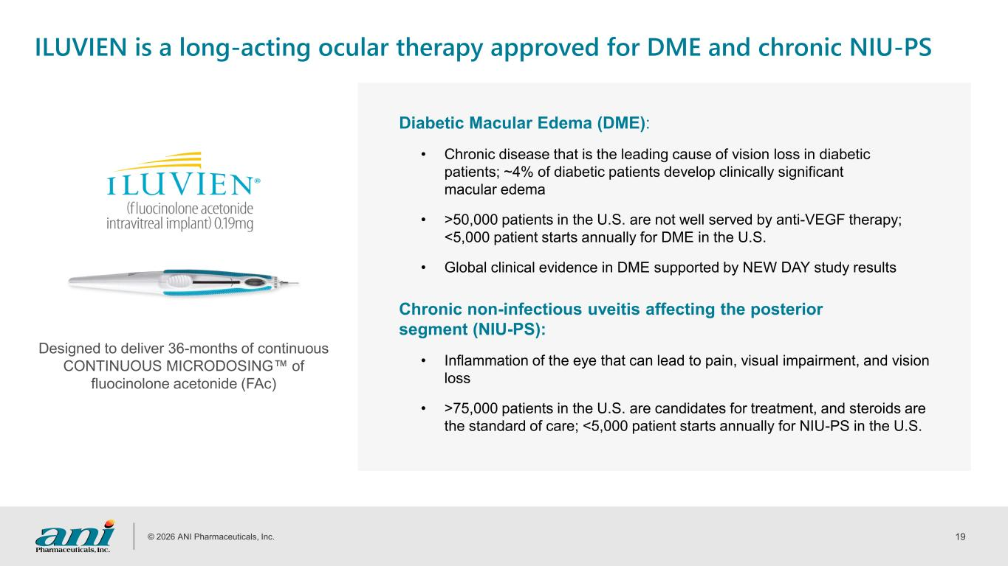
© 2026 ANI Pharmaceuticals, Inc. 19 ILUVIEN is a long-acting ocular therapy approved for DME and chronic NIU-PS Designed to deliver 36-months of continuous CONTINUOUS MICRODOSING of fluocinolone acetonide (FAc) Diabetic Macular Edema (DME): • Chronic disease that is the leading cause of vision loss in diabetic patients; ~4% of diabetic patients develop clinically significant macular edema • >50,000 patients in the U.S. are not well served by anti-VEGF therapy; <5,000 patient starts annually for DME in the U.S. • Global clinical evidence in DME supported by NEW DAY study results Chronic non-infectious uveitis affecting the posterior segment (NIU-PS): • Inflammation of the eye that can lead to pain, visual impairment, and vision loss • >75,000 patients in the U.S. are candidates for treatment, and steroids are the standard of care; <5,000 patient starts annually for NIU-PS in the U.S.

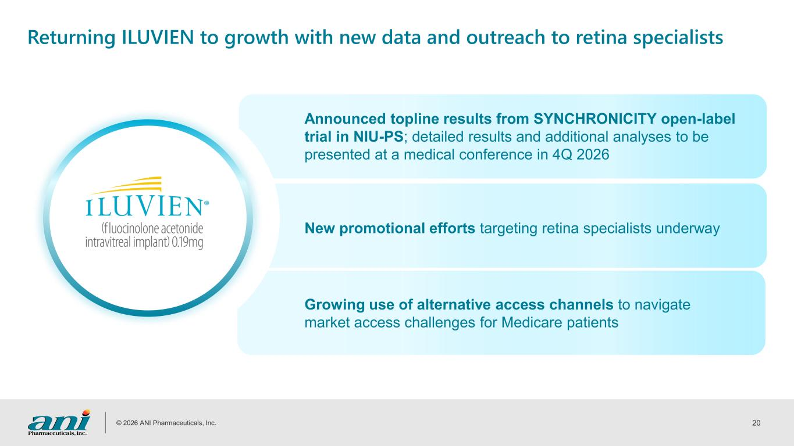
© 2026 ANI Pharmaceuticals, Inc. 20 Returning ILUVIEN to growth with new data and outreach to retina specialists Announced topline results from SYNCHRONICITY open-label trial in NIU-PS; detailed results and additional analyses to be presented at a medical conference in 4Q 2026 New promotional efforts targeting retina specialists underway Growing use of alternative access channels to navigate market access challenges for Medicare patients

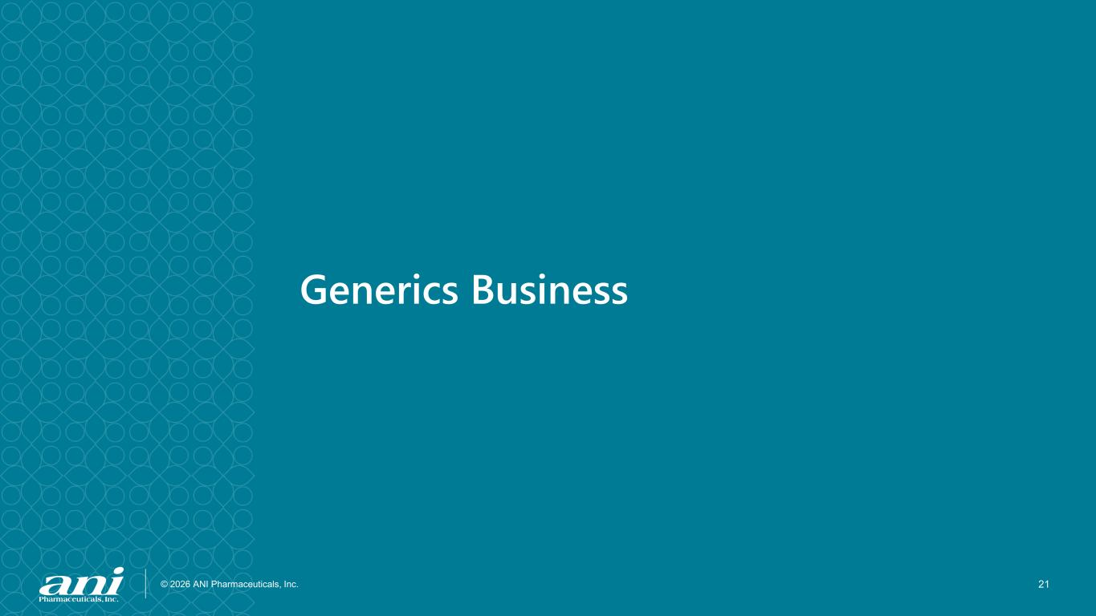
© 2026 ANI Pharmaceuticals, Inc. 21 Generics Business

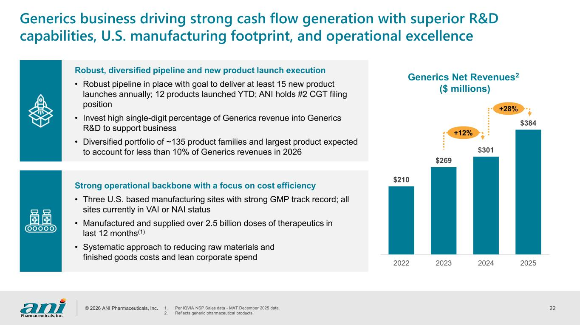
© 2026 ANI Pharmaceuticals, Inc. 22 $210 $269 $301 $384 2022 2023 2024 2025 Robust, diversified pipeline and new product launch execution • Robust pipeline in place with goal to deliver at least 15 new product launches annually; 12 products launched YTD; ANI holds #2 CGT filing position • Invest high single-digit percentage of Generics revenue into Generics R&D to support business • Diversified portfolio of ~135 product families and largest product expected to account for less than 10% of Generics revenues in 2026 Strong operational backbone with a focus on cost efficiency • Three U.S. based manufacturing sites with strong GMP track record; all sites currently in VAI or NAI status • Manufactured and supplied over 2.5 billion doses of therapeutics in last 12 months(1) • Systematic approach to reducing raw materials and finished goods costs and lean corporate spend Generics business driving strong cash flow generation with superior R&D capabilities, U.S. manufacturing footprint, and operational excellence Generics Net Revenues2 ($ millions) +12% +28% 1. Per IQVIA NSP Sales data - MAT December 2025 data. 2. Reflects generic pharmaceutical products.

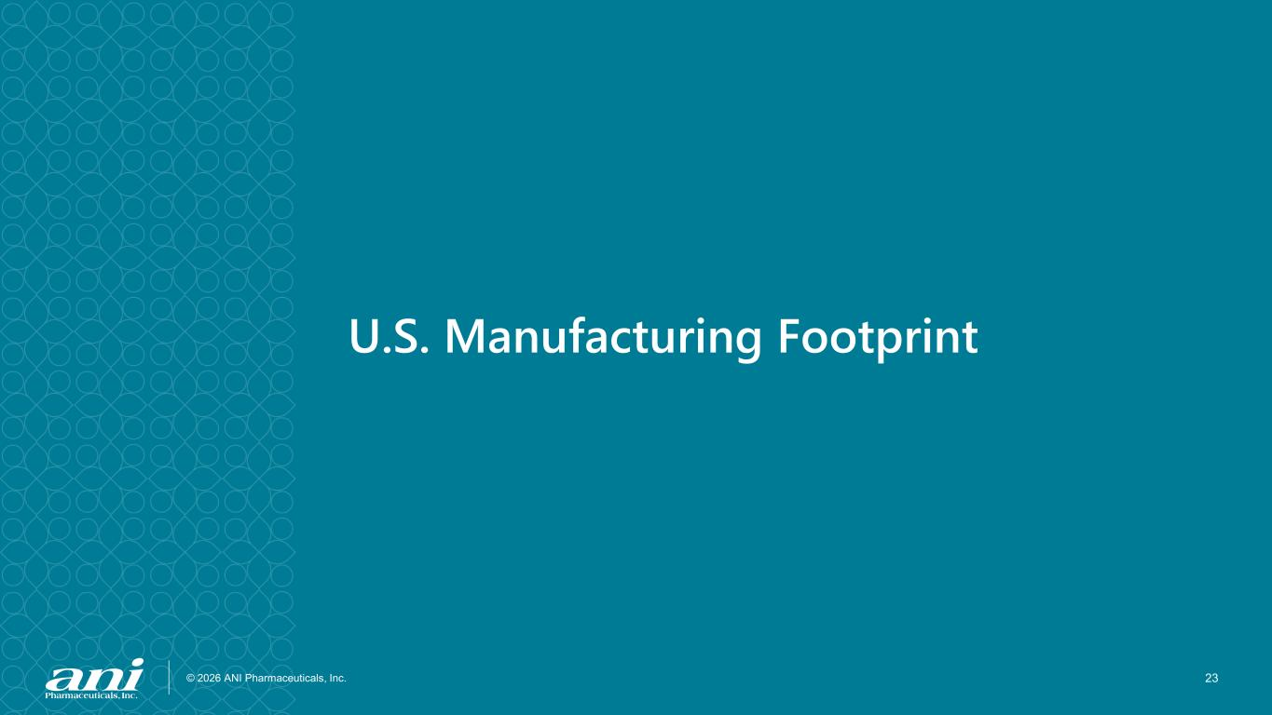
© 2026 ANI Pharmaceuticals, Inc. 23 U.S. Manufacturing Footprint

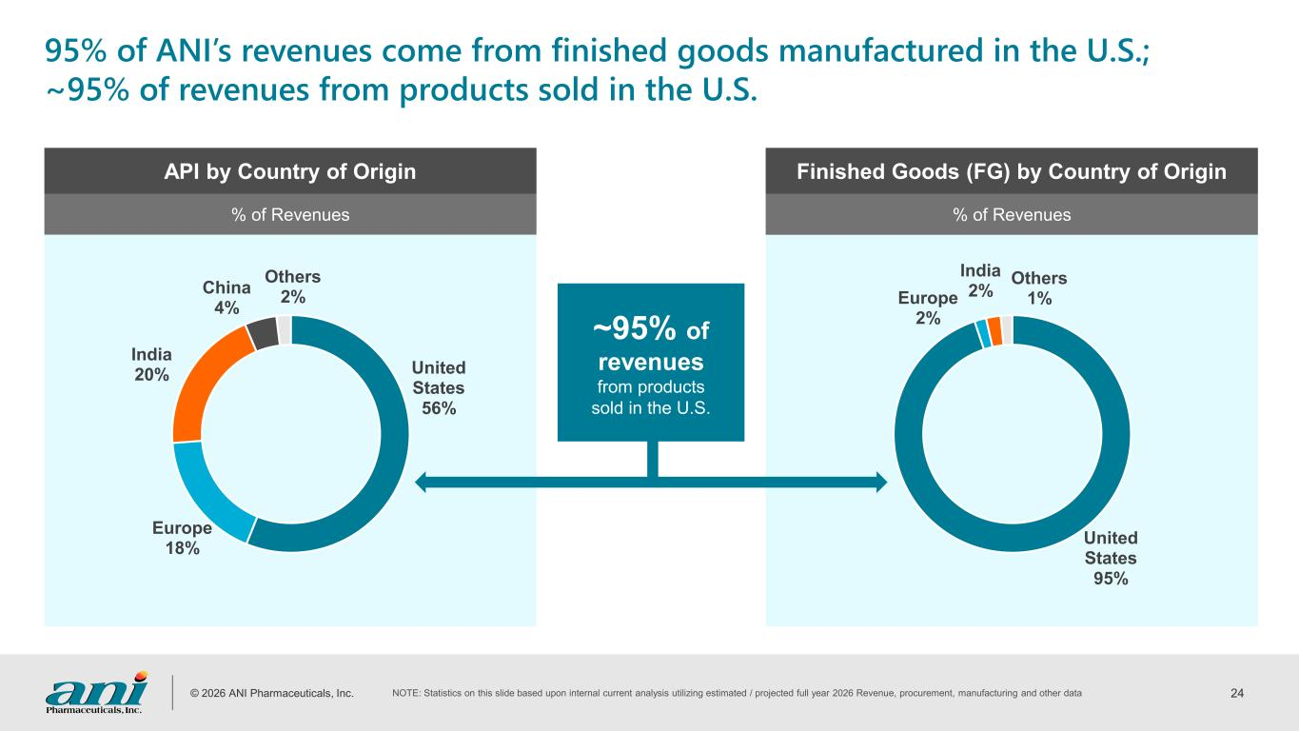
© 2026 ANI Pharmaceuticals, Inc. 24 United States 95% Europe 2% India 2% Others 1% United States 56% Europe 18% India 20% China 4% Others 2% 95% of ANI’s revenues come from finished goods manufactured in the U.S.; ~95% of revenues from products sold in the U.S. API by Country of Origin Finished Goods (FG) by Country of Origin % of Revenues % of Revenues ~95% of revenues from products sold in the U.S. NOTE: Statistics on this slide based upon internal current analysis utilizing estimated / projected full year 2026 Revenue, procurement, manufacturing and other data

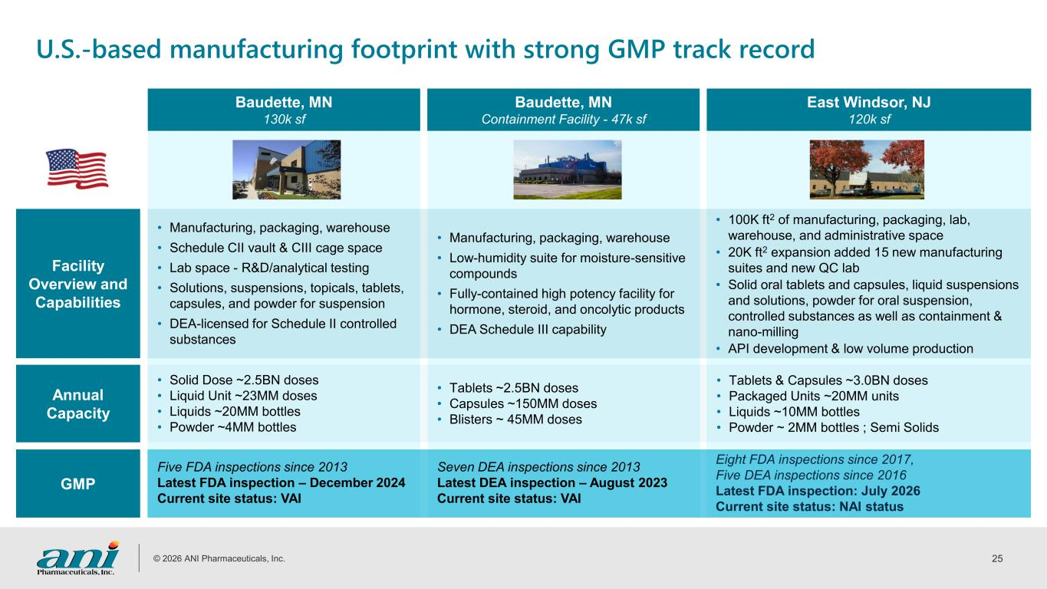
© 2026 ANI Pharmaceuticals, Inc. 25 U.S.-based manufacturing footprint with strong GMP track record Baudette, MN 130k sf Baudette, MN Containment Facility - 47k sf East Windsor, NJ 120k sf Facility Overview and Capabilities • Manufacturing, packaging, warehouse • Schedule CII vault & CIII cage space • Lab space - R&D/analytical testing • Solutions, suspensions, topicals, tablets, capsules, and powder for suspension • DEA-licensed for Schedule II controlled substances • Manufacturing, packaging, warehouse • Low-humidity suite for moisture-sensitive compounds • Fully-contained high potency facility for hormone, steroid, and oncolytic products • DEA Schedule III capability • 100K ft2 of manufacturing, packaging, lab, warehouse, and administrative space • 20K ft2 expansion added 15 new manufacturing suites and new QC lab • Solid oral tablets and capsules, liquid suspensions and solutions, powder for oral suspension, controlled substances as well as containment & nano-milling • API development & low volume production Annual Capacity • Solid Dose ~2.5BN doses • Liquid Unit ~23MM doses • Liquids ~20MM bottles • Powder ~4MM bottles • Tablets ~2.5BN doses • Capsules ~150MM doses • Blisters ~ 45MM doses • Tablets & Capsules ~3.0BN doses • Packaged Units ~20MM units • Liquids ~10MM bottles • Powder ~ 2MM bottles ; Semi Solids GMP Five FDA inspections since 2013 Latest FDA inspection – December 2024 Current site status: VAI Seven DEA inspections since 2013 Latest DEA inspection – August 2023 Current site status: VAI Eight FDA inspections since 2017, Five DEA inspections since 2016 Latest FDA inspection: July 2026 Current site status: NAI status


© 2026 ANI Pharmaceuticals, Inc. 26 Summary

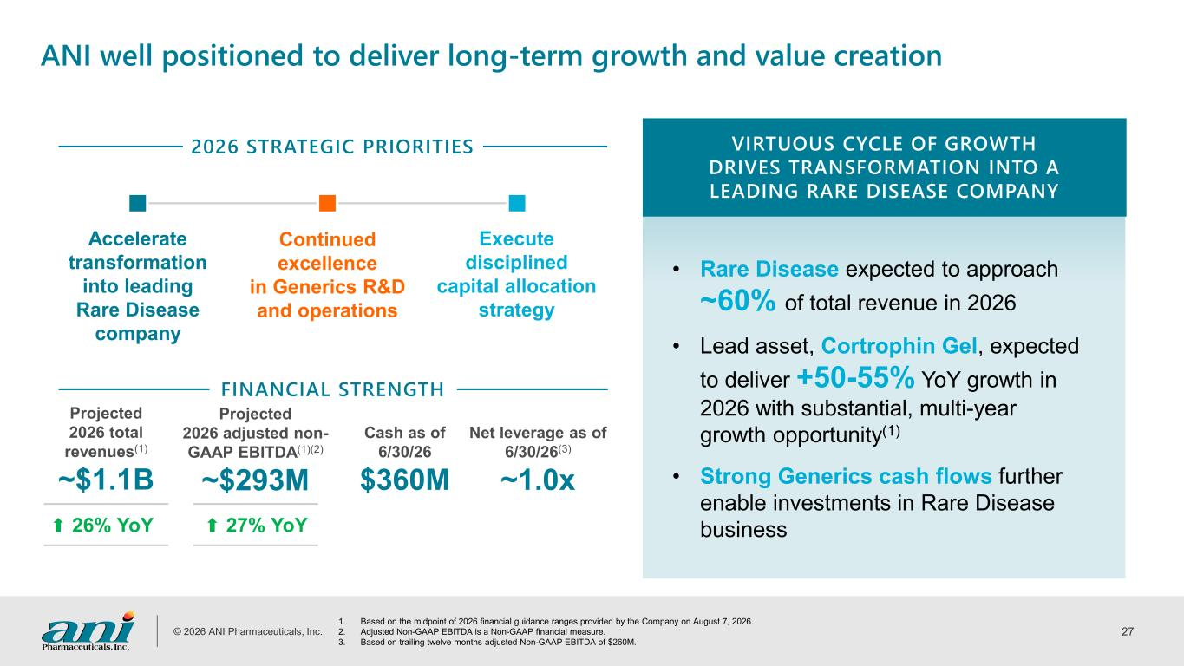
© 2026 ANI Pharmaceuticals, Inc. 27 ANI well positioned to deliver long-term growth and value creation • Rare Disease expected to approach ~60% of total revenue in 2026 • Lead asset, Cortrophin Gel, expected to deliver +50-55% YoY growth in 2026 with substantial, multi-year growth opportunity(1) • Strong Generics cash flows further enable investments in Rare Disease business VIRTUOUS CYCLE OF GROWTH DRIVES TRANSFORMATION INTO A LEADING RARE DISEASE COMPANY 1. Based on the midpoint of 2026 financial guidance ranges provided by the Company on August 7, 2026. 2. Adjusted Non-GAAP EBITDA is a Non-GAAP financial measure. 3. Based on trailing twelve months adjusted Non-GAAP EBITDA of $260M. Accelerate transformation into leading Rare Disease company Continued excellence in Generics R&D and operations Execute disciplined capital allocation strategy FINANCIAL STRENGTH 2026 STRATEGIC PRIORITIES Cash as of 6/30/26 $360M Net leverage as of 6/30/26(3) ~1.0x Projected 2026 total revenues(1) ~$1.1B Projected 2026 adjusted non- GAAP EBITDA(1)(2) ~$293M 27% YoY26% YoY


© 2026 ANI Pharmaceuticals, Inc. 28 Appendix

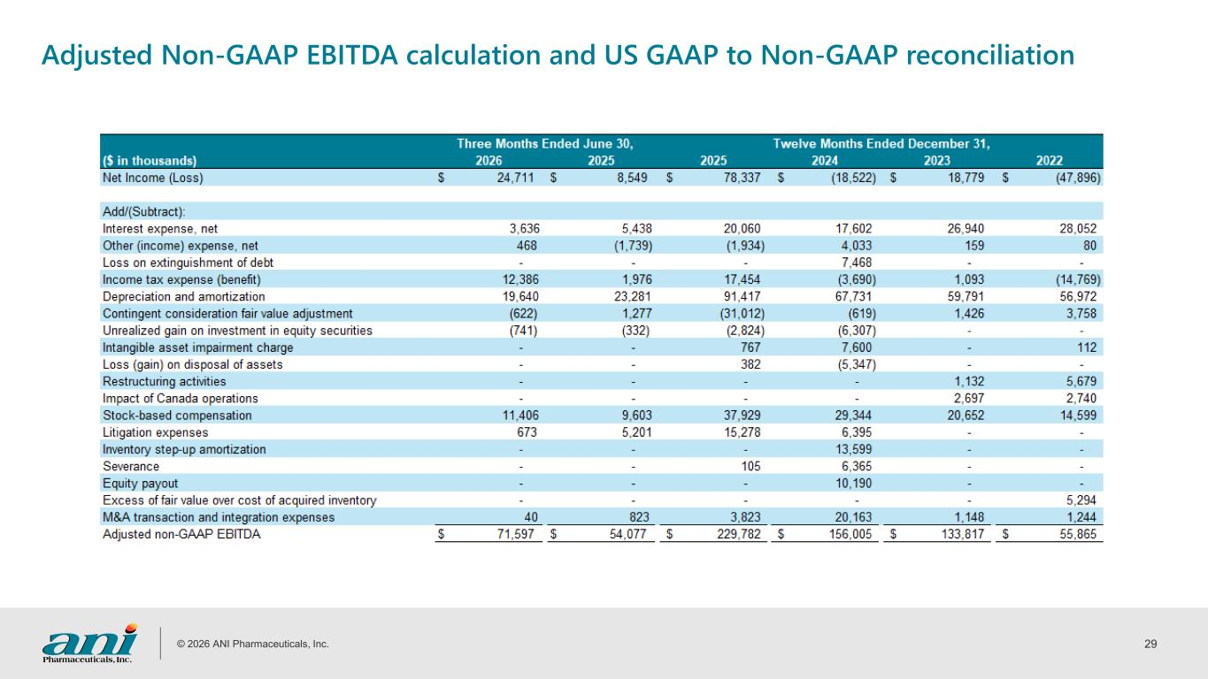
© 2026 ANI Pharmaceuticals, Inc. 29 Adjusted Non-GAAP EBITDA calculation and US GAAP to Non-GAAP reconciliation

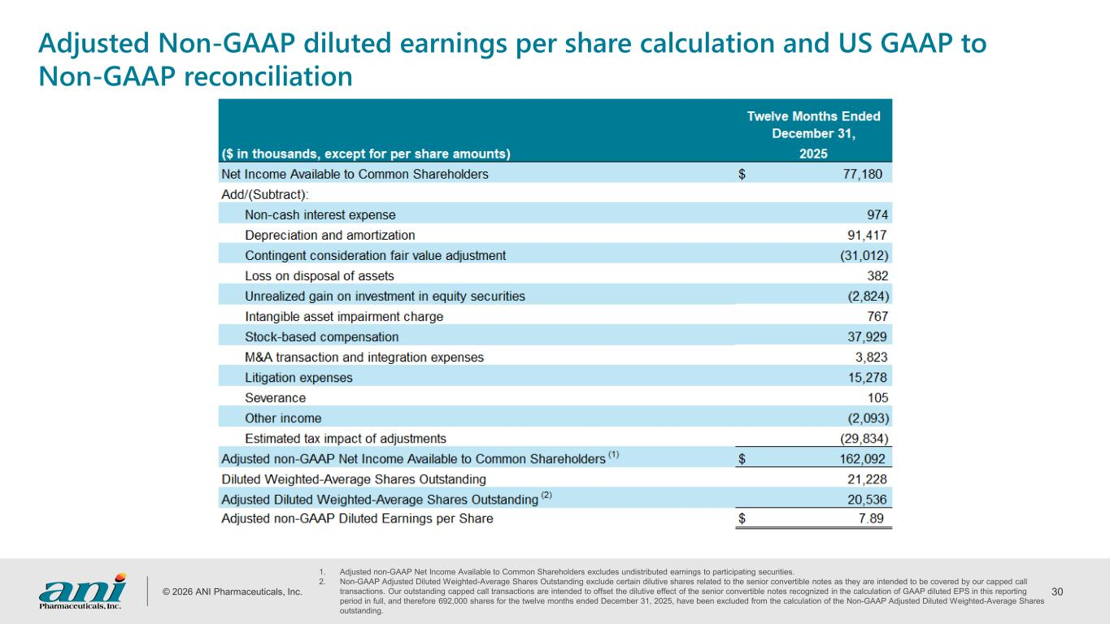
© 2026 ANI Pharmaceuticals, Inc. 30 Adjusted Non-GAAP diluted earnings per share calculation and US GAAP to Non-GAAP reconciliation 1. Adjusted non-GAAP Net Income Available to Common Shareholders excludes undistributed earnings to participating securities. 2. Non-GAAP Adjusted Diluted Weighted-Average Shares Outstanding exclude certain dilutive shares related to the senior convertible notes as they are intended to be covered by our capped call transactions. Our outstanding capped call transactions are intended to offset the dilutive effect of the senior convertible notes recognized in the calculation of GAAP diluted EPS in this reporting period in full, and therefore 692,000 shares for the twelve months ended December 31, 2025, have been excluded from the calculation of the Non-GAAP Adjusted Diluted Weighted-Average Shares outstanding.

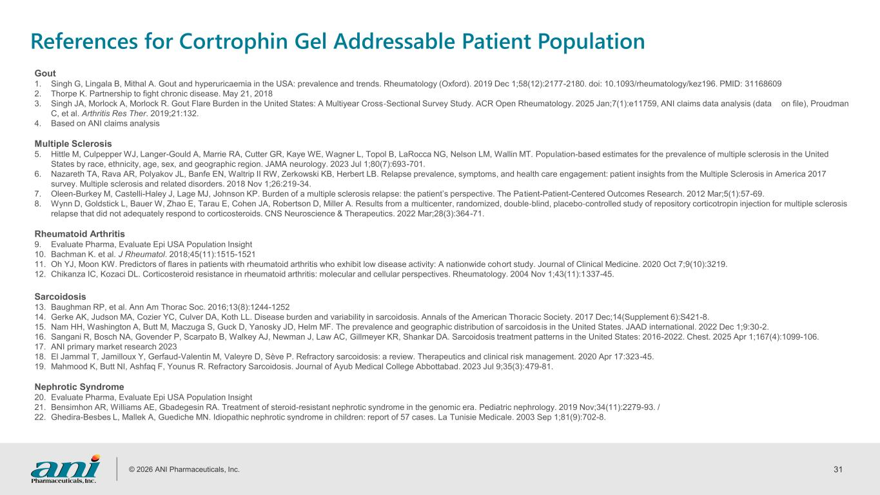
© 2026 ANI Pharmaceuticals, Inc. 31 References for Cortrophin Gel Addressable Patient Population Gout 1. Singh G, Lingala B, Mithal A. Gout and hyperuricaemia in the USA: prevalence and trends. Rheumatology (Oxford). 2019 Dec 1;58(12):2177-2180. doi: 10.1093/rheumatology/kez196. PMID: 31168609 2. Thorpe K. Partnership to fight chronic disease. May 21, 2018 3. Singh JA, Morlock A, Morlock R. Gout Flare Burden in the United States: A Multiyear Cross‐Sectional Survey Study. ACR Open Rheumatology. 2025 Jan;7(1):e11759, ANI claims data analysis (data on file), Proudman C, et al. Arthritis Res Ther. 2019;21:132. 4. Based on ANI claims analysis Multiple Sclerosis 5. Hittle M, Culpepper WJ, Langer-Gould A, Marrie RA, Cutter GR, Kaye WE, Wagner L, Topol B, LaRocca NG, Nelson LM, Wallin MT. Population-based estimates for the prevalence of multiple sclerosis in the United States by race, ethnicity, age, sex, and geographic region. JAMA neurology. 2023 Jul 1;80(7):693-701. 6. Nazareth TA, Rava AR, Polyakov JL, Banfe EN, Waltrip II RW, Zerkowski KB, Herbert LB. Relapse prevalence, symptoms, and health care engagement: patient insights from the Multiple Sclerosis in America 2017 survey. Multiple sclerosis and related disorders. 2018 Nov 1;26:219-34. 7. Oleen-Burkey M, Castelli-Haley J, Lage MJ, Johnson KP. Burden of a multiple sclerosis relapse: the patient’s perspective. The Patient-Patient-Centered Outcomes Research. 2012 Mar;5(1):57-69. 8. Wynn D, Goldstick L, Bauer W, Zhao E, Tarau E, Cohen JA, Robertson D, Miller A. Results from a multicenter, randomized, double‐blind, placebo‐controlled study of repository corticotropin injection for multiple sclerosis relapse that did not adequately respond to corticosteroids. CNS Neuroscience & Therapeutics. 2022 Mar;28(3):364-71. Rheumatoid Arthritis 9. Evaluate Pharma, Evaluate Epi USA Population Insight 10. Bachman K. et al. J Rheumatol. 2018;45(11):1515-1521 11. Oh YJ, Moon KW. Predictors of flares in patients with rheumatoid arthritis who exhibit low disease activity: A nationwide cohort study. Journal of Clinical Medicine. 2020 Oct 7;9(10):3219. 12. Chikanza IC, Kozaci DL. Corticosteroid resistance in rheumatoid arthritis: molecular and cellular perspectives. Rheumatology. 2004 Nov 1;43(11):1337-45. Sarcoidosis 13. Baughman RP, et al. Ann Am Thorac Soc. 2016;13(8):1244-1252 14. Gerke AK, Judson MA, Cozier YC, Culver DA, Koth LL. Disease burden and variability in sarcoidosis. Annals of the American Thoracic Society. 2017 Dec;14(Supplement 6):S421-8. 15. Nam HH, Washington A, Butt M, Maczuga S, Guck D, Yanosky JD, Helm MF. The prevalence and geographic distribution of sarcoidosis in the United States. JAAD international. 2022 Dec 1;9:30-2. 16. Sangani R, Bosch NA, Govender P, Scarpato B, Walkey AJ, Newman J, Law AC, Gillmeyer KR, Shankar DA. Sarcoidosis treatment patterns in the United States: 2016-2022. Chest. 2025 Apr 1;167(4):1099-106. 17. ANI primary market research 2023 18. El Jammal T, Jamilloux Y, Gerfaud-Valentin M, Valeyre D, Sève P. Refractory sarcoidosis: a review. Therapeutics and clinical risk management. 2020 Apr 17:323-45. 19. Mahmood K, Butt NI, Ashfaq F, Younus R. Refractory Sarcoidosis. Journal of Ayub Medical College Abbottabad. 2023 Jul 9;35(3):479-81. Nephrotic Syndrome 20. Evaluate Pharma, Evaluate Epi USA Population Insight 21. Bensimhon AR, Williams AE, Gbadegesin RA. Treatment of steroid-resistant nephrotic syndrome in the genomic era. Pediatric nephrology. 2019 Nov;34(11):2279-93. / 22. Ghedira-Besbes L, Mallek A, Guediche MN. Idiopathic nephrotic syndrome in children: report of 57 cases. La Tunisie Medicale. 2003 Sep 1;81(9):702-8.

